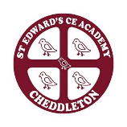
St Edward’s CE Academy Cheddleton
Community Newsletter April 2026

During our last half term, we explored the Easter story in a variety of ways, linking to our RE curriculum. Our Christian Council invited all children to bring a flower cutting or foliage to decorate our Easter cross. The Christian Council then worked together to help prepare and decorate the cross ready for it to be displayed in our Community Garden. Our EYFS children worked with their families at home to create Easter Gardens that were shared with everyone on our school playgrounds before being displayed alongside our Easter Cross in the Community Garden. If you were able to stop by our Community Garden over Easter, we do hope that the cross and gardens brought you as much joy as they did for us.
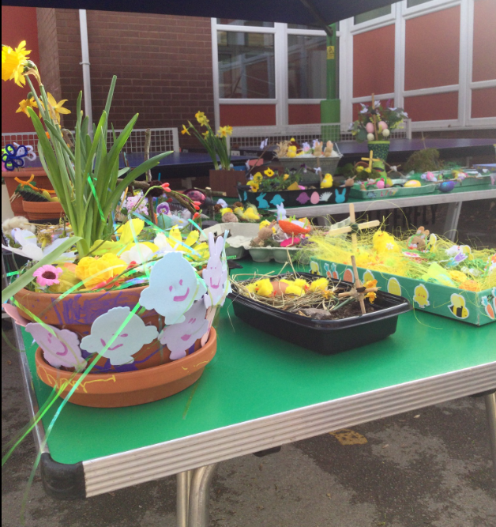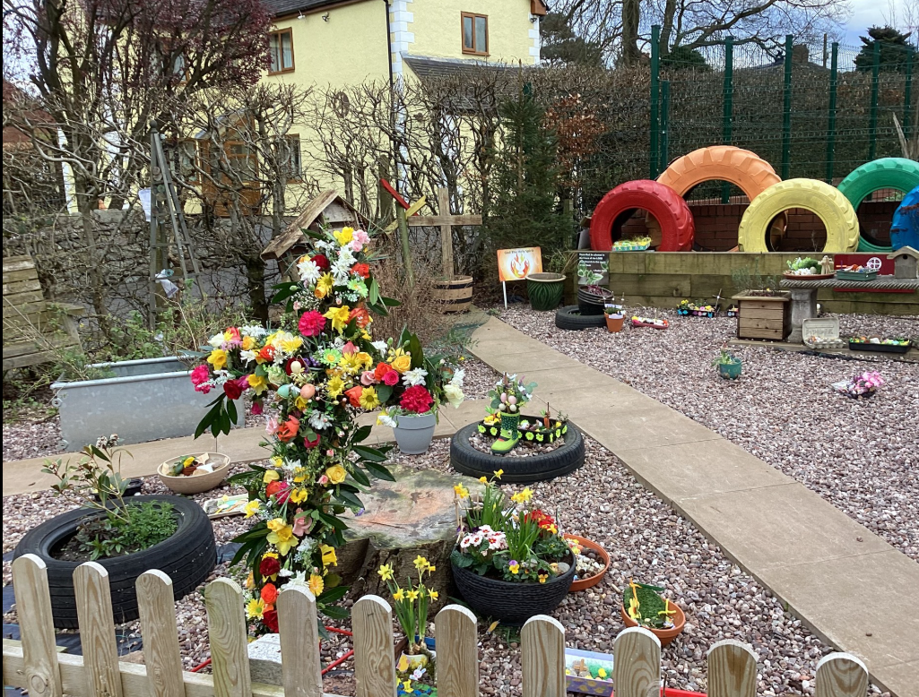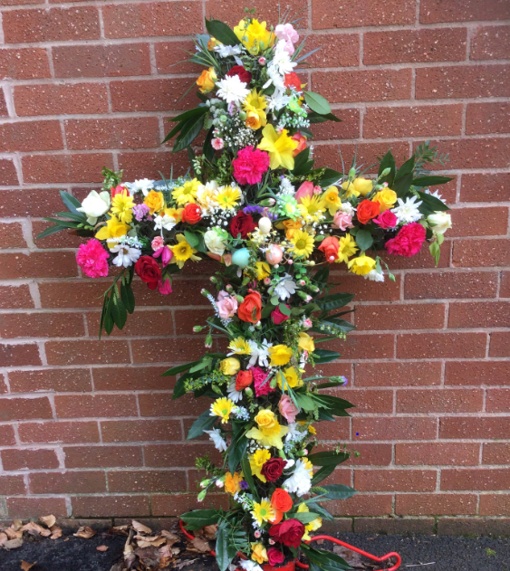

We are very fortunate to have strong links with both St Edward’s Church and St Andrew’s Methodist Church. We always look forward to Reverend Henry’s visitor worship and, last half term, we particularly enjoyed him leading us on the journey through Lent and Easter and helping us to grow in our understanding. Our Year 4 children were invited to take part in an Easter Hope Journey at St Andrew’s Methodist Church where they engaged with a variety of creative activities and workshops to support their understanding of the Easter story, including exploring different crosses from around the world. We are so very grateful to our church communities for supporting our school community to flourish.

Our KS2 children visited the Lakeside Art Gallery in Nottingham to support and enhance our art curriculum. The day started with a tour of the gallery where they saw some original Andy Warhol pieces of art. The children had the opportunity to recreate some of his portraits as well as working together as a team to create artwork of influential figures inspired by his artistic style. In the afternoon, they enjoyed a walk around the lake and drew parts of the landscape. A wonderful experience that was enjoyed by all!

We ended the half term with a whole school visit to Peak Wildlife Park. This was the result of our successful entry for the Attraction Action Primary Project in celebration of Staffordshire Day. As part of the project, our school is contributing to the Staffordshire Day display at the park on May 1st by designing and creating large 3D animal models made from recycled materials. Our sculptures will be made entirely from recycled materials, helping us to promote creativity, sustainability and care for our environment.

On return to school following the Easter holidays, we were very proud to learn that we have been awarded the afPE Quality Mark with Distinction for ‘demonstrating outstanding commitment to improvement in Physical Education, School Sport and Physical Activity’. The validator highlighted that PE is at the heart of our school’s vision, that we have strong outcomes for all pupils, including those with SEND and, due to physical activity being fully integrated across the curriculum, we have highly positive pupil attitudes, excellent engagement and a whole school ethos where being active is a valued and shared expectation. In addition to this, we have also achieved an FA Equal Access Award due to our commitment to providing equal opportunities for girls in football. This award is given to those that have worked to expand girls' football programs, break down barriers, and empower female athletes both in the curriculum and extra-curricular activities.

Did you know that children can join our school nursery from their third birthday? You can use Think2 Funding, the 30 hours Childcare Scheme or pay for the sessions you require. You can also use the funding for wraparound care in Brambles which is open from 7.30am until 6pm, including holidays. Last summer, we were fortunate to receive funding to enhance and develop our outstanding Early Years provision. If you, or anyone you know is looking for a place for their child and you would like to come and have a look at our provision, please contact the school office on 01538 714840 and we would be happy to arrange this for you.

