Staffordshire University Academies Trust |  |   Trust Policy Document Personalised for SEAC
Approved by: | Trust Board SEAC LAC | Issue date: | September 2024 | Review date: | Following Trust Review
Policy Owner: | A Hordern | Page: 1 of 61
Audience: | Trustees  Staff  Pupils   Local Academy Council  Parents  General Public 
SEAC Online Safety Policy

Ethos and Context of Our Academy
St Edward’s Academy Cheddleton (SEAC) is a Church of England school and has the values promoted by Christ, as shown in the Bible, at its heart. Our Christian Distinctiveness is embodied in what you see, hear and feel through our academy ethos, culture, values and curriculum. We are an inclusive academy where all God’s children, and adults, are treated with dignity and respected for difference, diversity and ways of living. We encourage all members of our community to grow and flourish within the context of our Christian belief and practice regardless of challenges, age, ethnicity, gender, identity, learning difficulty, nationality, religion, sexual orientation or disability.

Our Vision
We will teach wisdom, model and expect respect for all. We will nurture compassion, responsibility, courage and perseverance, equipping our pupils for life in all its fullness as honest adults in our diverse and ever changing world. We aspire to work collaboratively with our academy, Multi-Academy Trust, local, national and global communities as by… Learning and Caring Together ‘…they will flourish in the courts of our God’ (Psalm 92:13)

Purpose

The purpose of this policy is to:
- Ensure the safety and wellbeing of children and staff when using digital technologies.
- Ensure that digital technologies are used appropriately by all who access them.
- Provide staff and volunteers with information to guide and support their approach to online safety.
- Meet statutory obligations and ensure that users of digital technology are protected from harm both on and off site.
- Ensure that, as an organisation, we operate in line with our values, and within the law, in terms of how we use online devices and services.
- Provide clarity about the use of electronic communications equipment, to ensure that they are accessed and used in a manner that is safe and deters users from accessing inappropriate materials.
- Promote awareness and to provide guidance to assist staff in providing safeguards to the children in our Trust.
- Safeguard learners and staff in using digital technology and in accordance with Keeping Children Safe in Education statutory guidance.
- Ensure that online safety is embedded in our practices.
- Protect our online systems and technology from harm.
- Embed online safety in our cultures and raise awareness of online safety practices, within and for our communities.

The DfE Keeping Children Safe in Education statutory guidance requires Local Authorities, Multi Academy Trusts, and schools in England to ensure learners are safe from harm:

“It is essential that children are safeguarded from potentially harmful and inappropriate online material. An effective whole school and college approach to online safety empowers a school or college to protect and educate pupils, students, and staff in their use of technology and establishes mechanisms to identify, intervene in, and escalate any concerns where appropriate.”

“Governing bodies and proprietors should ensure online safety is a running and interrelated theme whilst devising and implementing their whole school or college approach to safeguarding and related policies and procedures. This will include considering how online safety is reflected as required in all relevant policies and considering online safety whilst planning the curriculum, any teacher training, the role and responsibilities of the designated safeguarding lead (and deputies) and any parental engagement.”

The DfE Keeping Children Safe in Education guidance also recommends:

Reviewing online safety…Technology, and risks and harms related to it, evolve, and change rapidly. Schools and colleges should consider carrying out an annual review of their approach to online safety, supported by an annual risk assessment that considers and reflects the risks their children face.

The DfE Keeping Children Safe in Education guidance advises that:
The breadth of issues classified within online safety is considerable and ever evolving, but can be categorised into four areas of risk:

- Content: being exposed to illegal, inappropriate, or harmful content, for example: pornography, fake news, racism, misogyny, self-harm, suicide, anti-Semitism, radicalisation, and extremism.
- Contact: being subjected to harmful online interaction with other users; for example: peer to peer pressure, commercial advertising and adults posing as children or young adults with the intention to groom or exploit them for sexual, criminal, financial or other purposes.
- Conduct: online behaviour that increases the likelihood of, or causes, harm; for example, making, sending and receiving explicit images (e.g. consensual and nonconsensual sharing of nudes and semi-nudes and/or pornography, sharing other explicit images and online bullying, and
- Commerce: risks such as online gambling, inappropriate advertising, phishing and or financial
scams.

This Online Safety Policy:

- Sets expectations for the safe and responsible use of digital technologies for learning, administration, and communication.
- Allocates responsibilities for the delivery of the policy.
- Is regularly reviewed in a collaborative manner, taking account of online safety incidents and changes/trends in technology and related behaviours.
- Establishes guidance for staff in how they should use digital technologies responsibly, protecting themselves, the academies and the Trust, and how they should use this understanding to help safeguard learners in the digital world.
- Describes how academies will help to prepare learners to be safe and responsible users of online technologies.
- Establishes clear procedures to identify, report, respond to and record the misuse of digital technologies and online safety incidents, including external support mechanisms.
- Is supplemented by a series of related acceptable use agreements contained within the Acceptable Use Policy.
- Is made available to staff at induction, and to parents and carers during admission, and through normal communication channels in each Academy.
- Is published on the Trust website. A version which has been personalised by each Academy will also be published on their own website.

Scope of the Policy
Government guidance across the UK highlights the importance of safeguarding children and young people from harmful and inappropriate online material (Department for Education, 2019a). All adults who come into contact with children and young people in their work have a duty of care to safeguard and promote their welfare in accordance with the 1989 Children Act and Child Care Act 2000. The Children Act 2004 places a duty on organisations to safeguard and promote the well-being of children and young people; this encompasses online safety. The Counter Terrorism and Securities Act 2015 also requires schools to ensure that children and young people are safe from terrorist and extremist material on the internet.

A whole school approach to online safety helps to ensure that staff, Local Academy Council members, volunteers and parents teach children about online safety. The internet and online technology provides a wide variety of new opportunities for young people’s learning and growth, but it can also expose them to new types of risks.

The Education and Inspections Act 2006 empowers Principals/Head Teachers to such extent as is reasonable, to regulate the behaviour of pupils when they are off site and empowers members of staff to impose disciplinary penalties for inappropriate behaviour. This is pertinent to incidents of cyber-bullying and online safety incidents covered by this policy, which may take place outside of an Academy. The 2011 Education Act has regard to the searching for and of electronic devices and the deletion of data.

Having an online presence is now an integral part of children and young people’s lives. Social media, online games, websites and apps can be accessed through mobile phones, computers, laptops and tablets – all of which form a part of the online environment, therefore, online safety should form a fundamental part of safeguarding and child protection measures and procedures.

This policy applies to all members of SUAT’s community (including staff, pupils, volunteers, parents / carers, members of the Trust Board, members of the Local Academy Councils, visitors, community users, suppliers) who have access to and are users of SUAT and Academy ICT systems, both in and out of the educational / work setting. It also applies to the use of personal digital technology on Academy sites (where allowed).

SUAT and the Academies will manage online safety incidents and associated behaviour in a manner which is proportionate to the incident, to ensure that pupils and students learn in a supportive, caring and safe environment without fear of bullying and online safety threats, and to defend the right of every child and adult to be happy and secure inside and outside of the educational environment. Academies will, where known, inform parents/carers of incidents of inappropriate online safety behaviour that take place out of school.

This Online Safety Policy outlines the commitment of SUAT and our academies to safeguard members of our Trust community, online, in accordance with statutory guidance and best practice. There is an expectation that the required professional standards will be applied to online safety as in other aspects of school life i.e.,

policies and protocols are in place for the use of online communication technology between the staff and other
members of the Trust and wider community, using officially sanctioned mechanisms.

Schedule for Development, Monitoring and Review

This Online Safety Policy was approved by the Trust Board on: | 6th October 2023
The implementation of this Online Safety Policy will be monitored by: | Designated safeguarding leads  Online safety Team  Senior leadership teams
Monitoring will take place at regular intervals: | At least annually.  Academies will monitor the impact of the policy using:  - Logs of reported incidents  - Filtering and monitoring logs  - Internal monitoring data for network  activity  - Staff meetings and parental feedback forums  - Lesson observations and drop ins  - Briefing updates and refreshers for staff  - Safeguarding newsletter including Online Safety  - Online safety training  - Questionnaires - pupils, parents  - LAC link for Online Safety, Cyber Security and Safeguarding visits  - Pupil voice
Each LAC will receive a report on the implementation of the  Online Safety Policy generated by the monitoring group (which will include anonymous details of online safety incidents) at regular intervals: | At least once per year.
The Online Safety Policy will be reviewed annually, or more regularly in the light of any significant new technological developments, new threats to online safety or incidents that have taken place. The next anticipated review date will be: | September 2025
Should serious online safety incidents take place, the following external persons/agencies should be informed: | Staffordshire LADO  Police if appropriate  SUAT Central team

1. Roles and Responsibilities

To ensure the online safeguarding of members of our Trust community, it is important that all members of our community work together to develop safe and responsible online behaviours, learning from each other and from good practice elsewhere, reporting inappropriate online behaviours, concerns, and misuse as soon as these become apparent. While this will be a team effort, the following sections outline the online safety roles and responsibilities of individuals and groups within the MAT. It will be important for each individual Academy to ensure that there is a ‘separation of responsibility’ for roles within their setting.

The Trust Board and Local Academy Councils

The Trust Board are responsible for the approval of the Online Safety Policy.

Reviewing the effectiveness of the policy will be the responsibility of individual academies and their safeguarding leads, supported by Local Academy Council members, who will receive regular information about online safety incidents and monitoring reports. LAC members can review the effectiveness of the policy and arrangement by asking questions which are posed in the UKCIS document “Online Safety in Schools and Colleges – questions from the Governing Body,” for example.

This review will be carried out by the relevant link LAC member, Senior Leaders and the Safeguarding / Online Safety Lead, who will receive regular information about online safety incidents and monitoring reports.
A member of the LAC will take on the role of Online Safety LAC member, to include:
- Regular meetings with the Designated Safeguarding Lead / Online Safety Lead in their Academy.
- Regularly receiving (collated and anonymised) reports of online safety incidents.
- Checking that provision outlined in the Online Safety Policy (e.g. online safety education provision and staff training is taking place as intended).
- Ensuring that the filtering and monitoring provision is reviewed and recorded, at least annually. The review will be conducted by members of the SLT, the DSL, and the IT service provider and involve the responsible LAC member in-line with the DfE Filtering and Monitoring Standards.
- Reporting back to the full LAC.
- Receiving (at least) basic cyber-security training to enable LAC members to ensure that academies meet the DfE Cyber-Security Standards.
- Membership of the Academy Online Safety Group.

The LAC will also support their Academy in encouraging parents/carers and the wider community to become engaged in online safety activities.

Reports from the LAC will be referred to the Trust Board via Governor Hub.

Principal and Senior Leaders
- The Principal has a duty of care for ensuring the safety (including online safety) of members of their Academy community and fostering a culture of safeguarding. Though the day-to-day responsibility for online safety is held by the Designated Safeguarding Lead, as defined in Keeping Children Safe in Education.
- The Principal and the Senior Leadership Team should be aware of the procedures to be followed in the event of a serious online safety allegation being made against a member of staff.
- The Principal and Senior Leaders are responsible for ensuring that the Designated Safeguarding Lead / Online Safety Lead, IT provider/technical staff, and other relevant staff, carry out their responsibilities effectively. All staff must receive suitable training to enable them to carry out their roles and the DSL / OSL should be able to train other colleagues, as relevant.
- The Principal and Senior Leaders will ensure that there is a system in place to allow for monitoring and support of those in school who carry out the internal online safety monitoring role.
- The Principal and Senior Leadership Team will either receive regular monitoring reports directly from the system, or from the Designated Safeguarding Lead / Online Safety Lead, and be made immediately aware of a safeguarding issue.
- The Principal and Senior Leaders will work with the responsible LAC member, the designated safeguarding lead (DSL) and IT service providers in all aspects of filtering and monitoring.
- The Principal and Senior Leaders will be responsible for ensuring that staff are appropriately trained in online safety and understand the procedures they must follow to a) help mitigate incidents and b) promptly report and manage incidents should they arise.

Designated Safeguarding Lead (DSL)
Should be trained in online safety issues and be aware of the potential for serious child protection / safeguarding issues to arise from:

- Sharing personal data.
- Access to illegal / inappropriate materials.
- Inappropriate on-line contact with adults / strangers.
- Potential or actual incidents of grooming.
- Cyber-bullying.

The DSL will:
- Hold the lead responsibility for online safety, within their safeguarding role.
- Receive relevant and regularly updated training in online safety to enable them to understand the risks associated with online safety and be confident that they have the relevant knowledge and up to date capability required to keep children safe whilst they are online.
- Meet regularly with the online safety LAC member to discuss current issues, review (anonymised) incidents and filtering and monitoring logs and ensuring that annual (at least) filtering and monitoring checks are carried out.
- Attend relevant LAC meetings/groups.
- Report regularly to Principal/ Senior Leadership Team.
- Be responsible for receiving reports of online safety incidents and handling them, and deciding whether to make a referral (in conjunction with the Head Teacher / SLT) by liaising with relevant agencies, ensuring that all incidents are recorded.
- Liaise with staff and IT providers on matters of safety and safeguarding and welfare (including online and digital safety).

Online Safety Lead (OSL) Anne Hordern

Should be trained in online safety issues and be aware of the potential for serious child protection / safeguarding issues to arise from:

- Sharing personal data.
- Access to illegal / inappropriate materials.
- Inappropriate on-line contact with adults / strangers.
- Potential or actual incidents of grooming.
- Cyber-bullying.

The Online Safety Lead will:
- Lead the Online Safety Group for their setting.
- Work closely on a day-to-day basis with the Designated Safeguarding Lead (DSL).
- Receive reports of online safety issues, being aware of the potential for serious child protection concerns and ensure that these are logged, to inform future online safety developments.
- Have a leading role in establishing and reviewing Academy online safety policies/documents.
- Promote an awareness of and commitment to online safety education / awareness raising across their Academy and beyond.
- Liaise with curriculum leaders to ensure that the online safety curriculum is planned, mapped, embedded and evaluated.
- Ensure that all staff are aware of the procedures that need to be followed in the event of an online safety incident taking place and the need to immediately report those incidents.
- Provide (or identify sources of) training and advice for staff/LAC members/parents/carers/learners.
- Liaise with technical staff, pastoral staff and support staff (as relevant).
- Receive regularly updated training to allow them to understand how digital technologies are used and are developing (particularly by learners) with regard to the areas defined in Keeping Children Safe in Education:
  - Content o Contact o Conduct
  - Commerce

Curriculum Leads
Curriculum Leads will work with the DSL/OSL to develop a planned and coordinated online safety education programme e.g. ProjectEVOLVE .

This will be provided according to each individual Academy’s arrangements, and for example, through: A discrete programme.

- PHSE and SRE programmes.
- A mapped cross-curricular programme.
- Assemblies and pastoral programmes.
- Through relevant national initiatives and opportunities e.g. Safer Internet Day and Anti-bullying week.

Teaching and Support Staff
Academy staff are responsible for ensuring that:

- They have an awareness of current online safety matters/trends and of the current Online Safety Policy and Academy practices.
- They understand that online safety is a core part of safeguarding.
- They have read, understood, and signed the staff acceptable use agreement (AUA).
- They immediately report any suspected misuse or problem to the designated person for investigation/action, in line with the Academy’s safeguarding procedures.
- All digital communications with learners and parents/carers are on a professional level and only carried out using official Academy and Trust systems.
- Online safety issues are embedded in all aspects of the curriculum and other activities.
- Learners understand and follow the Online Safety Policy and acceptable use agreements, have a good understanding of research skills and the need to avoid plagiarism and uphold copyright regulations.
- They supervise and monitor the use of digital technologies, mobile devices, cameras, etc., in lessons and other school activities (where allowed) and implement current policies regarding these devices.
- In lessons where internet use is pre-planned learners are guided to sites checked as suitable for their use and that processes are in place for dealing with any unsuitable material that is found in internet searches.
- Where lessons take place using live-streaming or video-conferencing, there is regard to national safeguarding guidance and local safeguarding policies.
- There is a zero-tolerance approach to incidents of online-bullying, sexual harassment, discrimination, hatred etc.
- They model safe, responsible, and professional online behaviours in their own use of technology, including out of school and in their use of social media.

ICT Manager / ICT Support Team Donna Swift and Staffs Tech
If an Academy has an IT / technology service provided by an outside contractor, it is the responsibility of the Academy to ensure that the provider carries out all the online safety measures that the Academy’s obligations and responsibilities require. It is also important that the provider follows and implements the Online Safety Policy and procedures.

The IT Provider / Academy IT Team is responsible for ensuring that:
- They are aware of and follow the school Online Safety Policy and Information Security Policy, to carry out their work effectively in line with these policies.
- The Academy technical infrastructure is secure and is not open to misuse or malicious attack as per the requirements of the Information Security Policy.
- The Academy the required online safety technical requirements as identified by the DfE Meeting Digital and Technology Standards in Schools & Colleges and guidance from MAT and other relevant sources.
There is clear, safe, and managed control of user access to networks and devices.
- They keep up to date with online safety technical information in order to effectively carry out their online safety role and to inform and update others as relevant.
- The use of technology is regularly and effectively monitored in order that any misuse/attempted misuse can be reported to the relevant person in the Academy for investigation and action.
- The filtering policy is applied and updated on a regular basis and its implementation is not the sole responsibility of any single person.
- Monitoring systems are implemented and regularly updated as agreed in Academy procedures and policies.
- That users may only access the networks and devices through a properly enforced password protection in which passwords are regularly changed (at least termly).
- Requests to amend filtering policy, such as unblocking uncategorised websites, are carefully reviewed before approving (approval for unblocking sites to be provided by the Principal).
- The firewall is functional and incorporates appropriate security rules to prevent a compromise to the network.
- That the use of the network / internet / remote access / email is regularly monitored in order that any misuse / attempted misuse can be reported to the relevant leader for investigation / action / sanction.
- That monitoring software / systems are implemented and updated as per this policy.
- Academy owned devices are appropriately restricted to ensure there is no misuse of cameras or online platforms such as unauthorised websites, social media, personal emails etc.
- Servers, wireless systems and cabling must be securely located and physical access restricted.

Learners
- Are responsible for using Academy digital technology systems in accordance with the relevant learner Acceptable Use Agreement and Online Safety Policy. This will include personal devices, if they are allowed.
- Should understand the importance of reporting abuse, misuse or access to inappropriate materials and know how to do so.
- Should know what to do if they or someone they know feels vulnerable when using online technology.
- Should understand the importance of adopting good online safety practice when using digital technologies out of school and realise that the Online Safety Policy covers their actions out of school, if related to their membership of the Academy.

Parents / Carers
Parents and carers play a crucial role in ensuring that their children understand the need to use the online services and devices in an appropriate way.
Academies will take every opportunity to help parents and carers understand these issues through:
- Publishing the Online Safety Policy on the website.
- Providing them with a copy of the learners’ Acceptable Use Agreement (including the AUA for parents).
- Publish information about appropriate use of social media relating to posts concerning the Academy.
- Seeking their permissions concerning digital images, cloud services etc. as relevant.
- Parents’/carers’ evenings, newsletters, website, social media and information about national/local online safety campaigns and literature.

Parents and carers will be encouraged to support the academies in:
- Reinforcing the online safety messages provided to learners in school

- The safe and responsible use of their children’s personal devices in the Academy (where this is allowed.

Community Users
Community users who access SUAT and Academy systems / website / learning platforms as part of the wider Academy provision will be expected to sign a Community User Acceptable Use Agreement before being provided with access to Academy/SUAT systems. Academies will ensure that appropriate security measures are implemented before any members of the community and visitors are permitted access to online environments using SUAT / Academy ICT systems (inclusive of Wi-Fi).

The Trust encourages the engagement of agencies/members of the community who can provide valuable contributions to the online safety provision and actively seeks to share its knowledge and good practice with other education providers and the community.

Online Safety Group
The Online Safety Group is a consultative team that has wide representation from an Academy’s community, with responsibility for issues regarding online safety and monitoring the Online Safety Policy including the impact of initiatives. The implementation of an Online Safety Group will depend on the size or structure of each Academy. Terms of Reference for the OSG are provided within the appendices to this policy. Members at SEAC include:
- Designated Safeguarding Lead
- Online Safety Lead
- Senior leaders
- Online safety LAC member (parent)
- Teacher and support staff members
- Learners (monitors and ambassadors)

Members of the Online Safety Group may support the following tasks in accordance with their role and responsibilities:

- The production/review/monitoring of the Online Safety Policy/documents.
- The production/review/monitoring of the filtering policy and requests for filtering changes.
- Mapping and reviewing the online safety education provision – ensuring relevance, breadth and progression and coverage.
- Reviewing network/filtering/monitoring/incident logs, where this does not conflict with data protection policies (Senior Leaders / DSL / Head Teacher only).
- Encouraging the contribution of learners to staff awareness, emerging trends and the online safety provision.
- Consulting stakeholders – including staff/parents/carers about the online safety provision.
- Monitoring improvement actions identified through use of the 360-degree safe self-review tool.

2. Acceptable Use

The Online Safety Policy and Acceptable Use Agreements define acceptable use within the academies and the Trust. The acceptable use agreements will be communicated/re-enforced through:

- Pupil Induction
- Staff induction
- Signage/displays.
- Posters/notices around where technology is used. • Communication with parents/carers (newsletter)
- Built into education sessions.
- Websites.
- INSET day (part of the declaration pack)
Activities which are considered acceptable and unacceptable can vary with the size/structure of the Academy and the ages of the learners. Each Academy must review, discuss and agree on these activities and to complete the following tables as guidance for members of the school community:
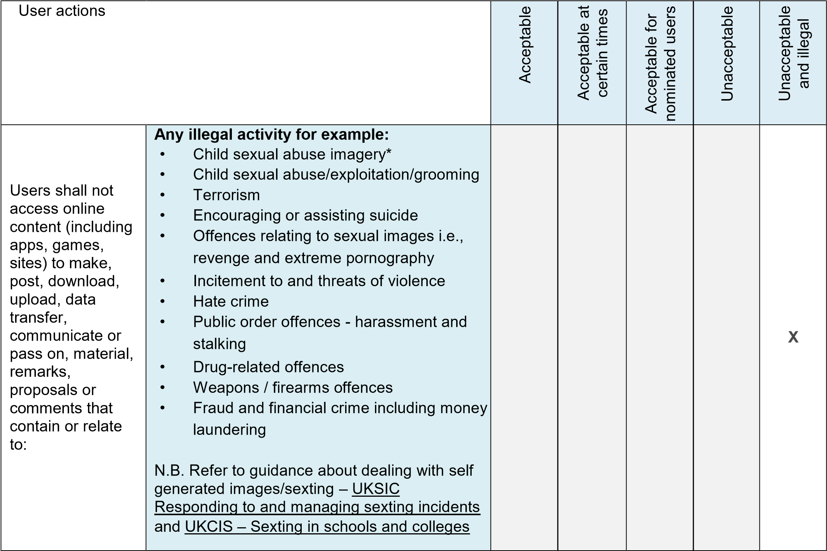

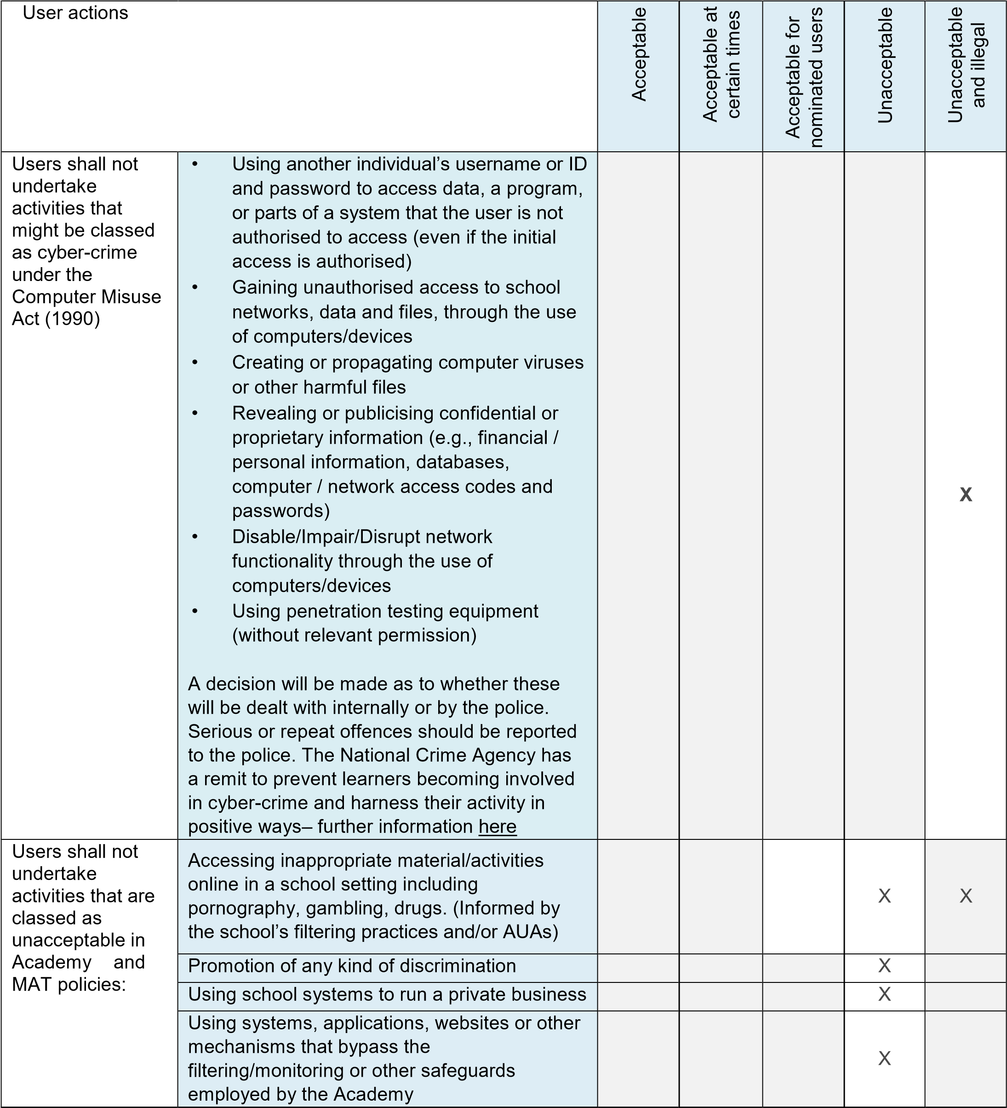

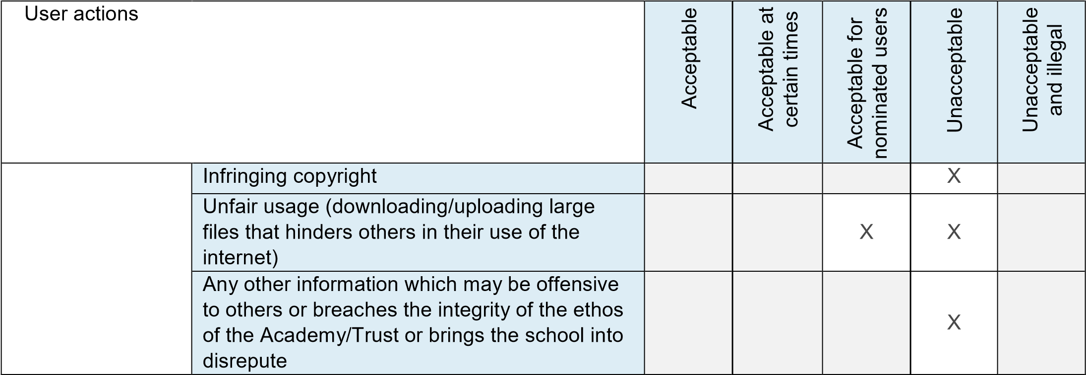

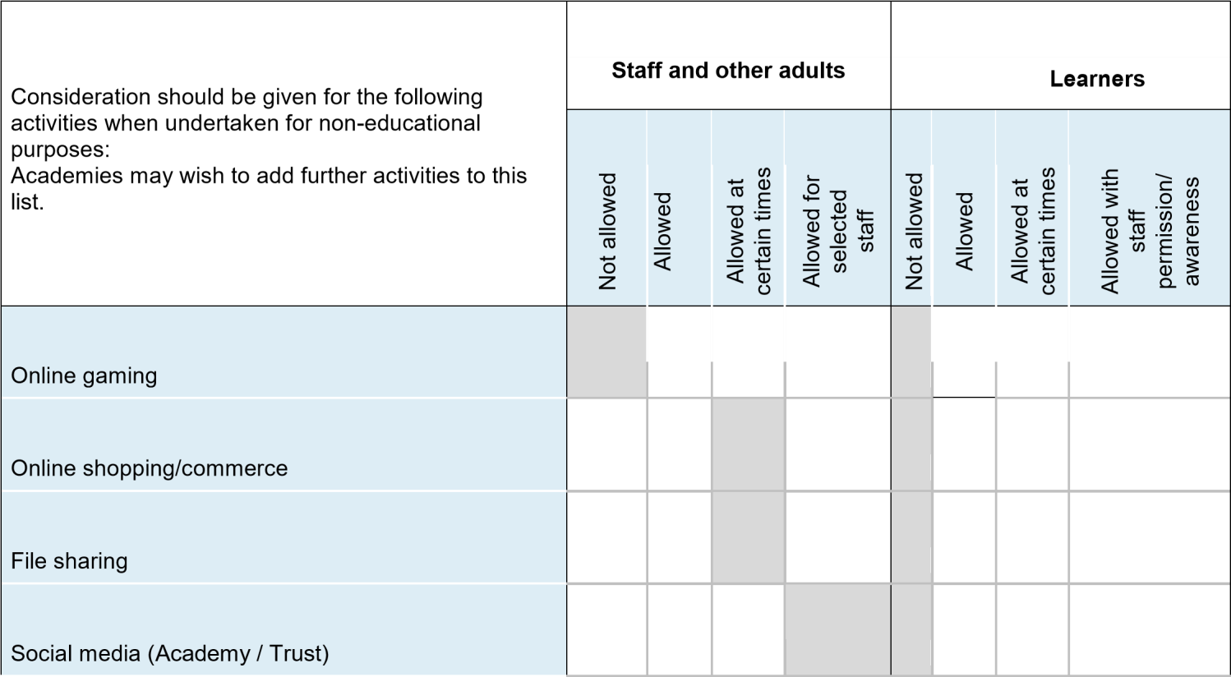

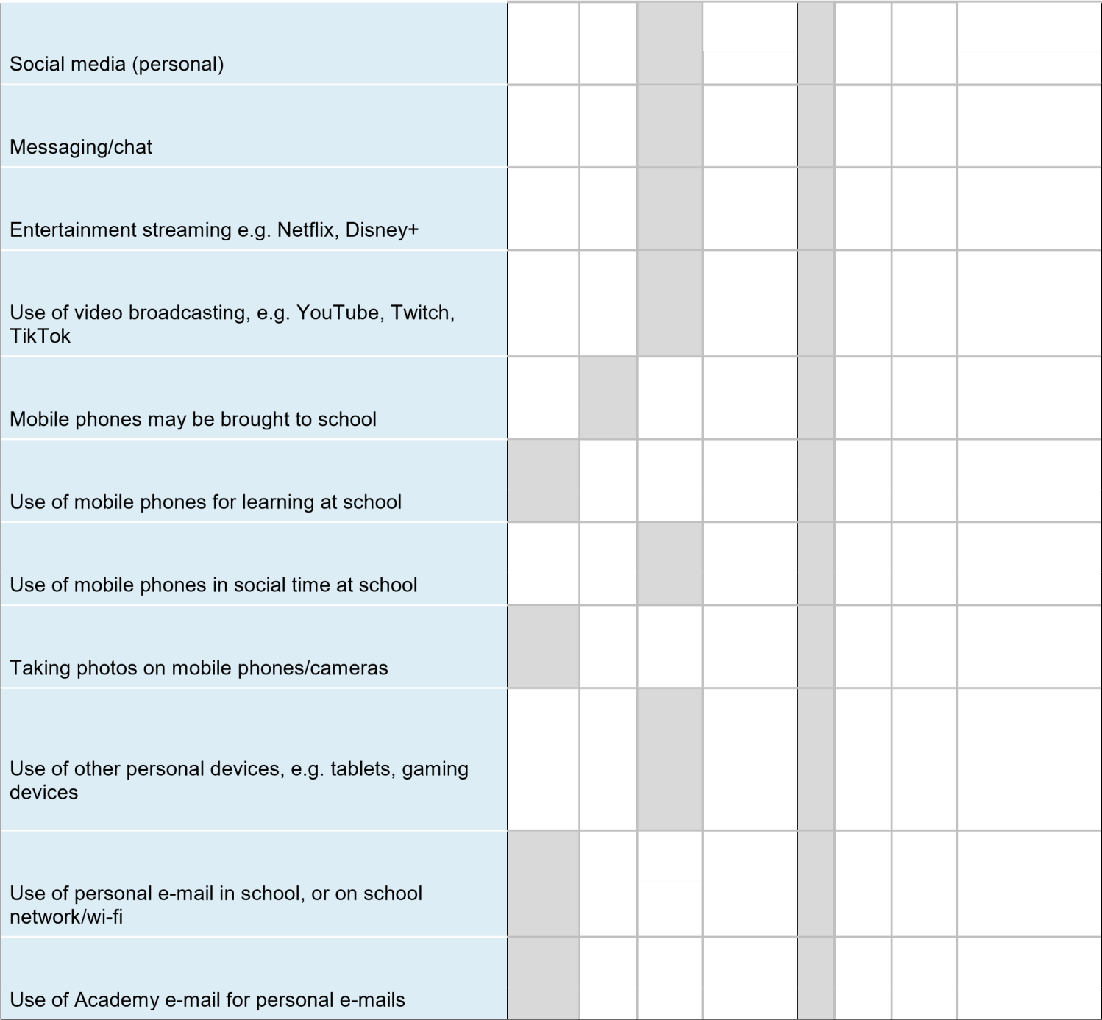

When using communication technologies, Academies consider the following as good practice:
- When communicating in a professional capacity, staff should ensure that the technologies they use are officially sanctioned by the Academy and only use Academy accounts.
- Any digital communication between staff and learners or parents/carers (e-mail, social media, learning platform, etc.) must be professional in tone and content. Personal e-mail addresses, text messaging or social media must not be used for these communications.
- Staff are expected to follow good practice when using personal social media regarding their own professional reputation and that of the school and its community.
- Users should immediately report to the nominated person regarding the receipt of any communication that makes them feel uncomfortable, is offensive, discriminatory, threatening or bullying in nature and must not respond to any such communication.
- Relevant policies and permissions should be followed when posting information online e.g., Academy website and social media. Only Academy e-mail addresses should be used to identify members of staff and learners within their communications.

3. Reporting and Responding

Each Academy will take all reasonable precautions to ensure online safety for all users, but recognises that incidents may occur inside and outside of school (with impact on the Academy) which will need intervention. Each Academy will ensure:

- There are clear reporting routes which are understood and followed by all members of the Academy community, which are consistent with Academy safeguarding procedures, and with the whistleblowing, complaints and managing allegations policies. Reporting systems, which can be used by all members of the Academy community, may be used, for example, SWGfL Whisper.
- All members of the Academy community will be made aware of the need to report online safety issues/incidents.
- Reports will be dealt with as soon as is practically possible once they are received, and will be prioritised according to their severity.
- The Designated Safeguarding Lead, Online Safety Lead and other responsible staff have appropriate skills and training to deal with online safety risks, and keep up to date with the latest safeguarding and online safety practices through ongoing CPD.
- If there is any suspicion that the incident involves any illegal activity or the potential for serious harm, the incident must be escalated through the agreed Academy safeguarding procedures. Harms and illegal activity can include:
  - Non-consensual images
  - Self-generated images
  - Terrorism/extremism
  - Hate crime/abuse
  - Fraud and extortion
  - Harassment/stalking
  - Child Sexual Abuse Material (CSAM)
  - Child Sexual Exploitation Grooming
  - Extreme Pornography
  - Sale of illegal materials/substances
  - Cyber or hacking offences under the Computer Misuse Act 1990
  - Copyright theft or piracy
- Any concern about staff misuse will be reported to the Principal, unless the concern involves the Principal, in which case the complaint is referred to the Chair of the LAC and the CEO of the Trust, and Local Authority as relevant to the case.
- Where there is no suspected illegal activity, devices may be checked using the following procedures:

- At least two senior members of staff should be involved in this process. This is vital to protect individuals if accusations are subsequently reported.
- Conduct the procedure using a designated device that will not be used by learners and, if necessary, can be taken off site by the police should the need arise (should illegal activity be subsequently suspected). Use the same device for the duration of the procedure.
- Ensure that the relevant staff have appropriate internet access to conduct the procedure, but also that the sites and content visited are closely monitored and recorded (to provide further protection).
- Record the URL of any site containing the alleged misuse and describe the nature of the content causing concern. It may also be necessary to record and store screenshots of the content on the machine being used for investigation. These may be printed, signed, and attached to the form.
- Once this has been completed and fully investigated, the group will need to judge whether this concern has substance or not. If it does, then appropriate action will be required and could include the following: o Internal response or discipline procedures o Involvement by local authority / MAT (as relevant) o Police involvement and/or action
- It is important that those reporting an online safety incident have confidence that the report will be treated seriously and dealt with effectively.
- There are support strategies in place e.g. peer support for those reporting or affected by an online safety incident.
- Incidents should be logged and logs should contain sufficient detail regarding the incident.
- Relevant staff are aware of external sources of support and guidance in dealing with online safety issues, e.g. local authority; police; Professionals Online Safety Helpline; Reporting Harmful Content; CEOP.
- Those involved in the incident will be provided with feedback about the outcome of the investigation and follow up actions (as relevant).
- Learning from the incident (or pattern of incidents) will be provided (as relevant and anonymously) to:
The below flowchart is available to staff to support the decision-making process for dealing with online safety incidents:

Please turn over.

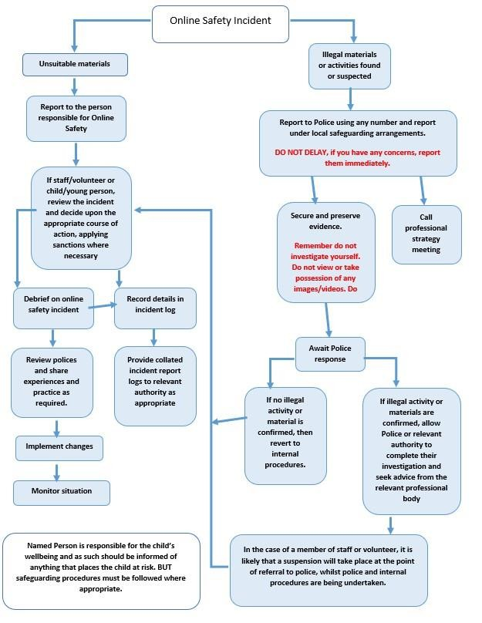

4. Academy Actions

It is more likely that academies will need to deal with incidents that involve inappropriate rather than illegal misuse. It is important that any incidents are dealt with as soon as possible and in a proportionate manner, and that members of the Academy community are aware that incidents have been dealt with. It is intended that incidents of misuse will be dealt with through normal behaviour/disciplinary procedures, which will be updated and adjusted in accordance with behaviour and HR policies and procedures.

Responding to Learner Actions

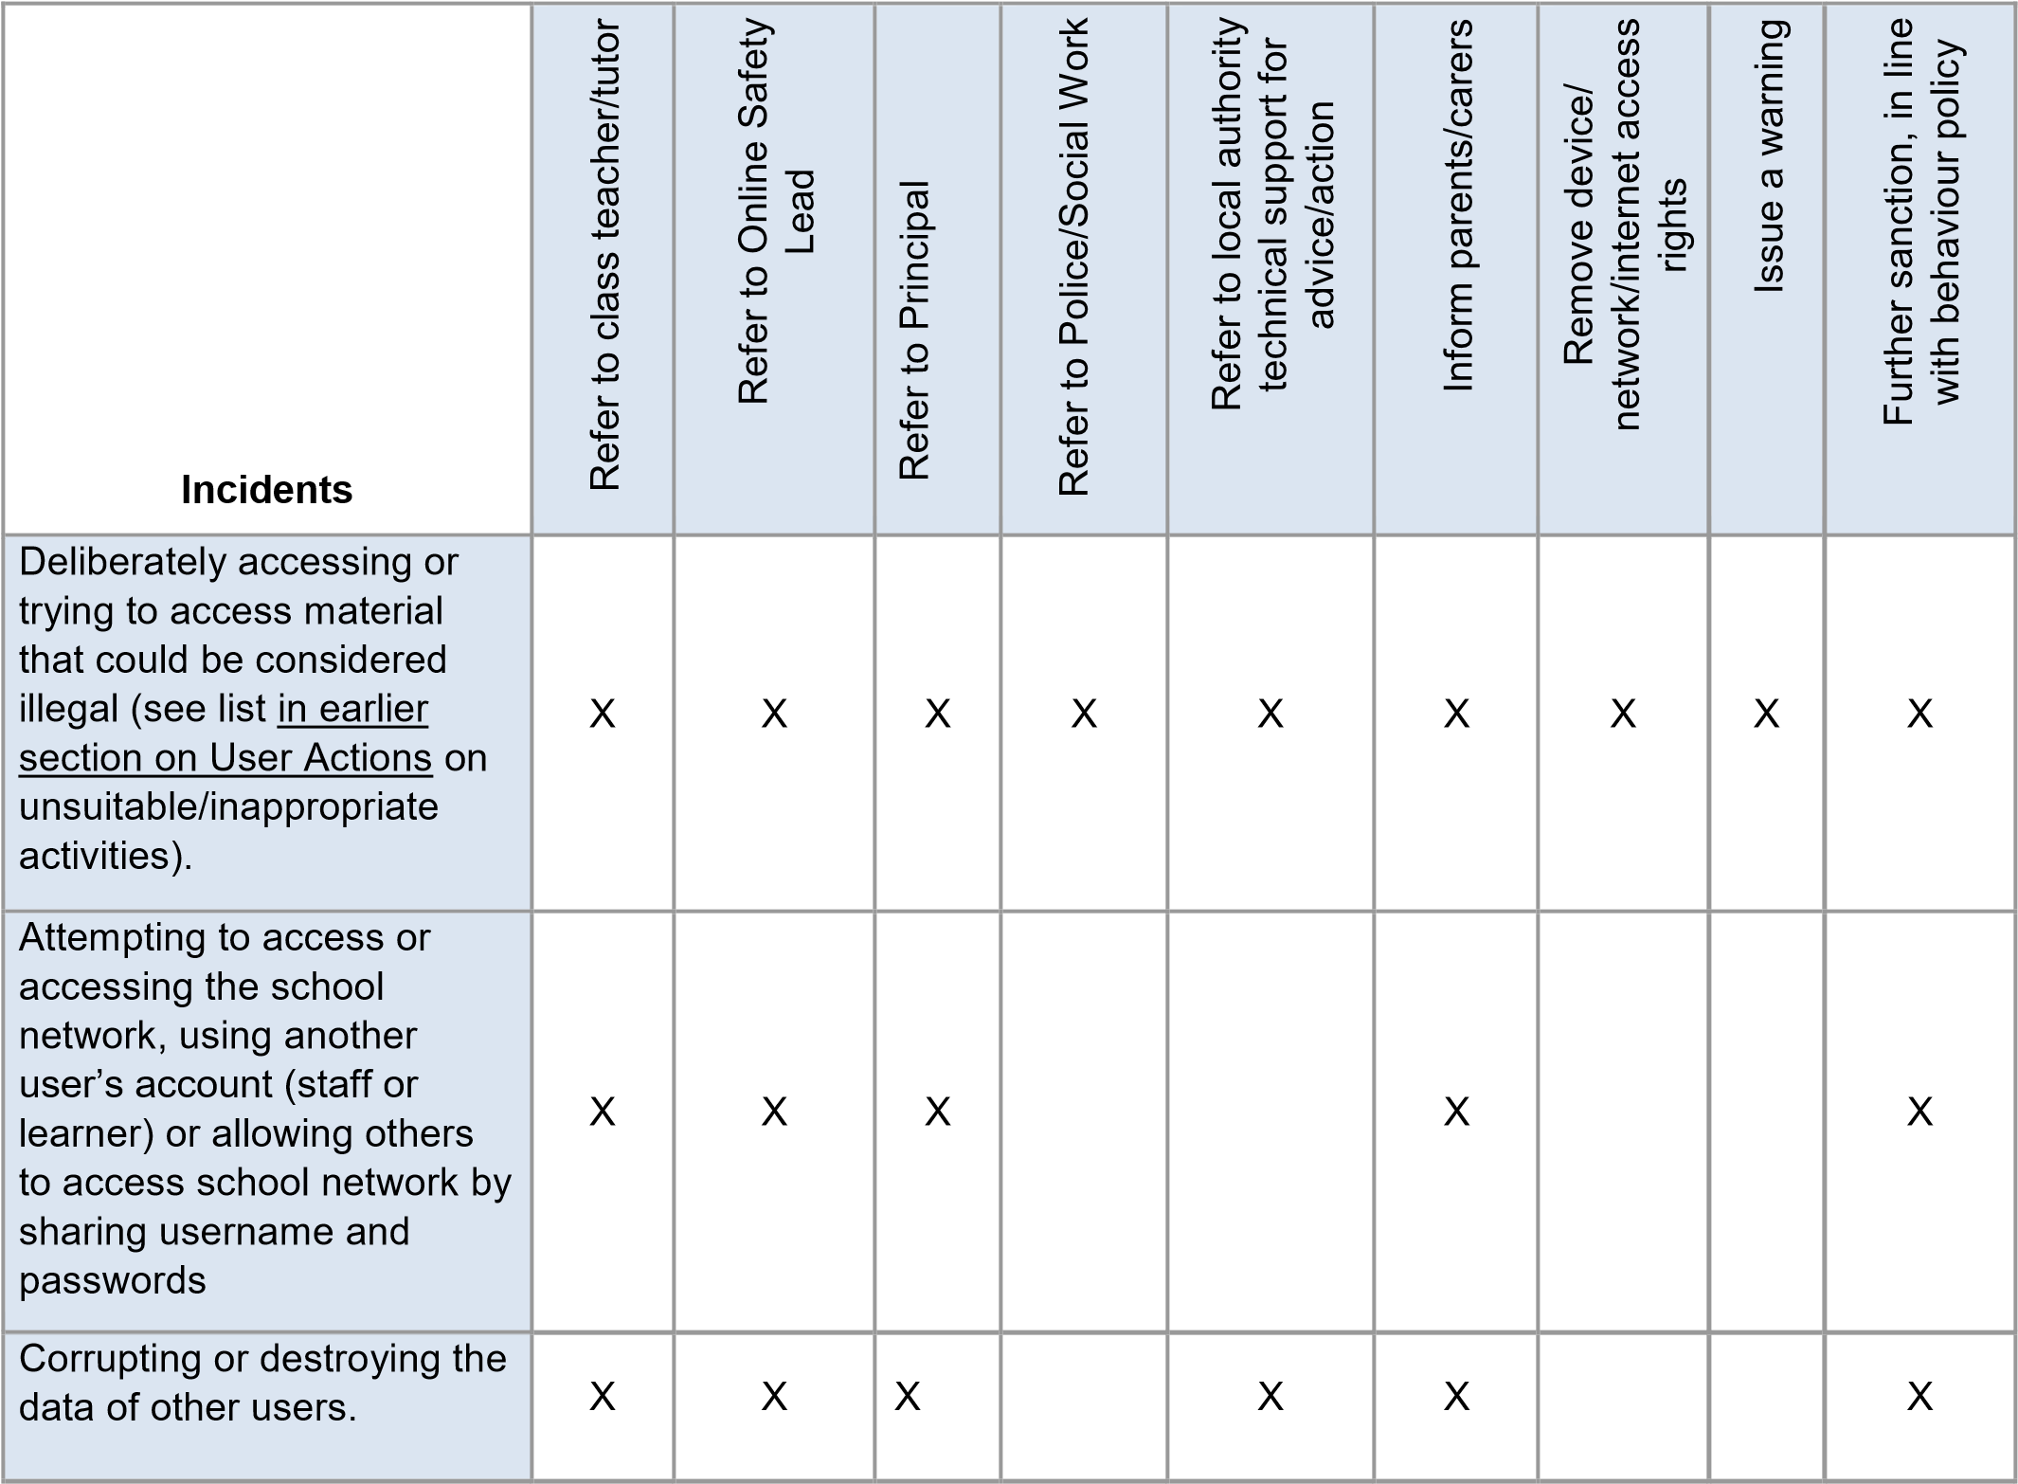
Sending an e-mail, text or message that is regarded as offensive, harassment or of a bullying nature | X | X | X+JC |  |  | X |  |  | X
Unauthorised downloading or uploading of files or use of file sharing. | X | X | X |  | X | X |  |  | X

Using proxy sites or other means to subvert the school’s filtering system. | X | X | X |  | X | X | X |  | X
Accidentally accessing offensive or pornographic material and failing to report the incident. | X | X | X |  | X | X | X |  | X
Deliberately accessing or trying to access offensive or pornographic material. | X | X | X | X | X | X | X | X | X
Receipt or transmission of material that infringes the copyright of another person or infringes the Data Protection Act. | X | X | X |  |  | X | X |  | X
Unauthorised use of digital devices (including taking  images) | X | X | X |  |  | X |  | X | X
Unauthorised use of online services | X | X | X |  |  | X |  | X | X
Actions which could bring the school into disrepute or breach the integrity or the ethos of the school. | X | X | X |  | X | X |  |  | X
Continued infringements of the above, following previous warnings or sanctions. | X | X | X | X | X | X | X | X | X

Responding to Staff Actions
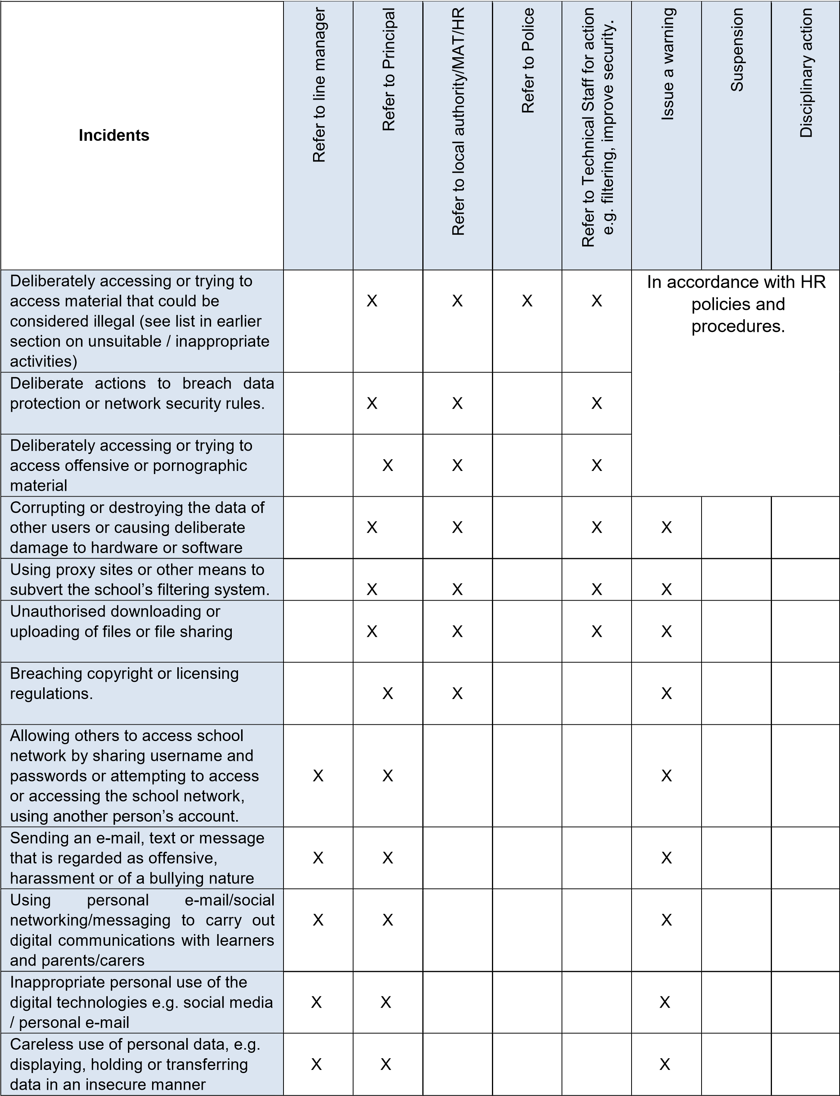
Actions which could compromise the staff member’s professional standing | X | X |  |  |  | X
Actions which could bring the school into disrepute or breach the integrity or the ethos of the Academy | X | X |  |  |  | X
Failing to report incidents whether caused by deliberate or accidental actions | X | X |  |  |  | X
Continued infringements of the above, following previous warnings or sanctions. | X | X | X |  |  |  |  | X

5. Online Safety Education and Training

Education – Pupils
Whilst regulation and technical solutions are very important, their use must be balanced by educating learners to take a responsible approach. The education of pupils in Online Safety is therefore an essential part of each Academy’s Online Safety and Safeguarding provision. Learners need the help and support of each Academy to recognise and avoid Online Safety risks and build their resilience.

Online safety should be a focus of the curriculum and staff should reinforce online safety messages across the curriculum. The online safety curriculum should be broad, relevant and provide progression, with opportunities for creative activities by:
- A planned online safety curriculum for all year groups matched against a nationally agreed framework e.g. Education for a Connected World Framework by UKCIS/DCMS and the SWGfL, ProjectEvolve, which is regularly taught in a variety of contexts.
- Lessons are matched to need, are age-related and build on prior learning.
- Lessons are context-relevant with agreed objectives leading to clear and evidenced outcomes.
- Learner needs and progress are addressed through effective planning and assessment.
- Digital competency is planned and effectively threaded through the appropriate digital pillars in other curriculum areas e.g., PHSE; SRE; Literacy etc.
- It incorporates/makes use of relevant national initiatives and opportunities e.g. Safer Internet Day and Anti-bullying week.
- The programme will be accessible to learners at different ages and abilities such as those with additional learning needs or those with English as an additional language.
- Vulnerability is actively addressed as part of a personalised online safety curriculum e.g., for victims of abuse and SEND.
- Learners should be helped to understand the need for the learner acceptable use agreement and encouraged to adopt safe and responsible use both within and outside school. Acceptable use is reinforced across the curriculum, with opportunities to discuss how to act within moral and legal boundaries online, with reference to the Computer Misuse Act 1990.
Lessons and further resources are available on the CyberChoices site.
- Staff should act as good role models in their use of digital technologies the internet and mobile devices.
- In lessons where internet use is pre-planned, it is best practice that learners should be guided to sites checked as suitable for their use and that processes are in place for dealing with any unsuitable material that is found in internet searches.
- Where learners are allowed to freely search the internet, staff should be vigilant in supervising the learners and monitoring the content of the websites the young people visit.
- It is accepted that from time to time, for good educational reasons, students may need to research topics, (e.g. racism, drugs, discrimination) that would normally result in internet searches being blocked. In such a situation, staff should be able to request the temporary removal of those sites from the filtered list for the period of study. Any request to do so, should be auditable, with clear reasons for the need.
- The online safety education programme should be relevant and up to date to ensure the quality of learning and outcomes.
- SEAC refer to National Online Safety for curriculum learning.
- Reflections incorporate safeguarding/online safety
- Online Safety is taught as a standalone subject
- Routine safe guarding newsletters include online safety updates and reminders
Academies acknowledge, learn from, and use the skills and knowledge of learners in the use of digital technologies. Academies recognise the potential for this to shape the online safety strategy for the school community and how this contributes positively to the personal development of young people.
Their contribution is recognised through:
- Mechanisms to canvass learner feedback and opinion.
- Appointment of digital leaders/anti-bullying ambassadors/peer mentors (or similar groups).
- The online safety group has learner representation.
- Learners contribute to the online safety education programme e.g. peer education, digital leaders leading lessons for younger learners, online safety campaigns.
- Learners designing/updating acceptable use agreements.
- Contributing to online safety events with the wider school community e.g. parents’ evenings, family learning programmes etc.

Staff / Volunteers
All staff will receive online safety training and understand their responsibilities, as outlined in this policy. Training will be offered as follows:

- A planned programme of formal online safety and data protection training will be made available to all staff. This will be regularly updated and reinforced. An audit of the online safety training needs of all staff will be carried out regularly.
- Data protection, cyber security, online safety and cyber security training will be undertaken at the point of induction and carried out annually thereafter. ▪ A data protection and safeguarding induction.
- The training will be an integral part of each Academy’s annual safeguarding programme.
- All new staff will receive online safety training as part of their induction programme, ensuring that they fully understand the Online Safety Policy and Acceptable Use Agreements. It includes explicit reference to classroom management, professional conduct, online reputation and the need to model positive online behaviours.
- The online safety lead and designated safeguarding lead (or other nominated person) will receive regular updates through attendance at external training events, (e.g. UKSIC / SWGFL / MAT / LA / other relevant organisations) and by reviewing guidance documents released by relevant organisations.
- This Online Safety Policy and its updates will be presented to and discussed by staff in staff/team meetings/inset days.
- The designated safeguarding lead/online safety lead (or other nominated person) will provide advice/guidance/training to individuals as required.

LAC Members

LAC members should take part in online safety training/awareness sessions, which will be particularly important for those who are members of any sub-committee/group involved in technology/online safety/health and safety/safeguarding. This may be offered in several ways such as:
- Attendance at training provided by the local authority/MAT or other relevant organisation (e.g., SWGfL).
- Participation in Academy training / information sessions for staff or parents (this may include attendance at assemblies/lessons).
- Attending cyber security training, which is an annual requirement under the Risk Protection Arrangement’s cyber cover.

- A higher level of training will be made available to (at least) the Online Safety LAC Member. This will include:
- Cyber-security training (at least at a basic level via the NCSC).
- Training to allow the LAC member to understand the Academy’s filtering and monitoring provision, in order that they can participate in the required checks and review.

Families
Many parents and carers have only a limited understanding of online safety risks and issues, yet they play an essential role in the education of their children and in the monitoring/regulation of the children’s online behaviours.

The school will seek to provide information and awareness to parents and carers through

Regular communication, awareness-raising and engagement on online safety issues, curriculum activities and reporting routes.
- Regular opportunities for engagement with parents/carers on online safety issues through awareness workshops / parent/carer evenings etc.
- The learners – who are encouraged to pass on to parents the online safety messages they have learned in lessons and by learners leading sessions at parent/carer evenings.
- Letters, newsletters, websites, learning platform.
- High profile events / campaigns e.g. Safer internet day.
- Reference to the relevant web sites/publications, e.g. Swgfl; www.saferinternet.org.uk/; www.childnet.com/parents-and-carers (see appendix for further links/resources).
- Sharing good practice with other academies locally, within the Trust and across the Local Authority.

Adults and Agencies
Academies may wish to provide opportunities for local community groups and members of the wider community to gain from their online safety knowledge and experience. This may be offered through the following:
- Online safety messages targeted towards families and relatives.
- Providing family learning courses in use of digital technologies and online safety.
- Providing online safety information via the website and social media for the wider community.
- Supporting community groups, e.g. early years settings, childminders, youth/sports/voluntary groups to enhance their online safety provision (consider supporting these groups with an online safety review using 360 Groups or 360 Early Years).

6. Technology
Each Academy is responsible for ensuring that their infrastructure/network is as safe and secure as is reasonably possible (see Information Security Policy), and that procedures approved within this policy are implemented. All staff need to be made aware of policies and procedures in place on a regular basis and academies should explain that everyone is responsible for online safety and data protection.

Academies who have an external technology provider must ensure that the provider carries out all the online safety and security measures that would otherwise be the responsibility of the Academy, in accordance with the DfE’s Technology Standards for Schools and this Online Safety Policy.
Policies which support information security and data protection matters include the Data Protection Policy, Information Security Policy and Acceptable Use Policy.

7. Filtering and Monitoring
Each Academy’s filtering and monitoring provision should be agreed by the Head Teacher and Senior Leaders, taking advice from their IT Service Provider. This must be regularly reviewed (at least annually) and updated in response to changes in technology and patterns of online safety incidents/behaviours locally and nationally. The provision is required to meet the standards specified in the DfE’s technology standards for schools guidance.

Day to day management of filtering and monitoring systems requires the specialist knowledge of both safeguarding and IT staff to be effective. The DSL will have lead responsibility for safeguarding and online safety and the IT service provider will have technical responsibility.

The filtering and monitoring provision is reviewed (at least annually) by senior leaders, the Designated Safeguarding Lead and a LAC member with the involvement of the IT Service Provider as required.

Internet access should be filtered for all users. Differentiated internet access should be available for staff and customised filtering changes are managed by the Academy. Illegal content is filtered by the broadband or filtering provider by actively employing the Internet Watch Foundation URL list and other illegal content lists. Filter content lists must be regularly updated and internet use must be logged and frequently monitored. The monitoring process in each Academy must alert designated staff to breaches of the filtering policy, which are then acted upon in accordance with the procedures detailed within this policy. Where personal mobile devices are allowed internet access through the Academy network, filtering will be applied that is consistent with Academy practice.

Effective filtering and monitoring includes that:
- There is a filtering and monitoring system in place that safeguards staff and learners by blocking harmful, illegal and inappropriate content.
- There is a monitoring system that enables the prompt investigation of a potential safeguarding incident and outcomes are logged.
- Roles and responsibilities for the management of filtering and monitoring systems have been defined and allocated.
- The filtering and monitoring provision is reviewed at least annually and checked regularly.
- There is a defined and agreed process for making changes to the filtering or monitoring system that involves a senior leader in the agreement of the change.
- Mobile devices that access the Academy’s internet connection (whether Academy or personal devices) will be subject to the same filtering standards as other devices on the Academy systems.
- Academies can provide enhanced/differentiated user-level filtering through the use of the filtering system.

Checks on the filtering and monitoring system must be carried out by the designated member of staff, in particular when a safeguarding risk is identified, there is a change in working practice, for example, new technology is introduced. This includes:

- Discrimination: Promotes the unjust or prejudicial treatment of people on the grounds of the protected characteristics listed in the Equality Act 2010
- Drugs / Substance abuse: displays or promotes the illegal use of drugs or substances
- Extremism: promotes terrorism and terrorist ideologies, violence or intolerance
- Malware / Hacking: promotes the compromising of systems including anonymous browsing and other filter bypass tools as well as sites hosting malicious content
- Pornography: displays sexual acts or explicit images
- Piracy and copyright theft: includes illegal provision of copyrighted material
- Self Harm: promotes or displays deliberate self harm (including suicide and eating disorders)
- Violence: Displays or promotes the use of physical force intended to hurt or kill • Gambling
- Any malicious, harmful or inappropriate content

Any member of staff employed by SUAT who comes across an online safety issue does not investigate any further but immediately reports it to the Senior Leadership Team, Designated Safeguarding Lead or Principal/Head Teacher and takes the equipment out of use.

Filtering

The filtering of internet content provides an important means of preventing users from accessing material that is illegal or is inappropriate in an educational context. The filtering system cannot, however, provide a 100% guarantee that it will do so, as online content changes dynamically and new technologies are constantly being developed. It is important, therefore, to understand that filtering is only one element in a larger strategy for online safety and acceptable use. It is important that each Academy has a filtering policy to manage the associated risks and to provide preventative measures which are relevant to the situation in each setting. Academies are recommended to use the UK Safer Internet Centre Definitions to help them determine if their filtering system is appropriate, and can test their filtering for protection against illegal materials at: SWGfL Test Filtering.
The filtering system should be operational, up to date and applied to all:
- Users, including guest accounts.
- Academy / Trust owned devices.
- Devices using the school broadband connection.
The filtering system should:
- Filter all internet feeds, including any backup connections.
- Be age and ability appropriate for the users and be suitable for educational settings. • Handle multilingual web content, images, common misspellings and abbreviations.
- Identify technologies and techniques that allow users to get around the filtering such as vpns and proxy services and block them.
- Provide alerts when any web content has been blocked.
Mobile and app content is often presented in a different way to web browser content. If users access content in this way, academies should get confirmation from their provider as to whether they can provide filtering on mobile or app technologies. A technical monitoring system should be applied to devices using mobile or app content to reduce the risk of harm.
Academies should ensure that their filtering system meets the following principles:

- Age appropriate, differentiated filtering – includes the ability to vary filtering strength appropriate to age and ability to understand the complexities of internet content.
- Circumvention – the extent and ability to identify and manage technologies and techniques used to circumvent the system, for example VPN, proxy services and DNS over HTTPS.
- Control - has the ability and ease of use that allows the Academy to control the filter themselves to permit or deny access to specific content.
- Filtering Policy – the filtering provider publishes a rationale that details their approach to filtering with classification and categorisation as well as over blocking. Each Academy should have access to their filtering policy.
- Group/Multi-site Management – the ability for deployment of central policy and central oversight or dashboard.
- Identification - the filtering system should have the ability to identify users.
- Mobile and App content – mobile and app content is often delivered in entirely different mechanisms from that delivered through a traditional web browser. The filter system must also block inappropriate content via mobile and app technologies (beyond typical web browser delivered content). Where mobile devices are taken off the school infrastructure or fall outside
of this filtering, then other appropriate device level filtering will be in place to ensure safeguarding (such as Mobile Device Management tools).
- Multiple language support – the ability for the system to manage relevant languages.
- Reporting mechanism – the ability to report inappropriate content for access or blocking.
- Reports – the system offers clear historical information on the websites visited by Academy users.

All use of Academy internet access is logged and the logs are regularly monitored by the DSL, senior leadership team, and IT Support provider where appropriate. Whenever any inappropriate use is detected, it will be followed up by the DSL or member of the Senior Leadership Team depending on the severity of the incident.
Effective filtering includes:
- Each Academy manages access to content across its systems for all users and on all devices using Academy internet provision. The filtering provided is required to meet the standards defined in the DfE
- Filtering standards for schools and colleges and the guidance provided in the UK Safer Internet Centre Appropriate filtering.
- Illegal content (e.g., child sexual abuse images) is filtered by the broadband or filtering provider by actively employing the Internet Watch Foundation URL list and the police assessed list of unlawful terrorist content, produced on behalf of the Home Office. Content lists are regularly updated.
- There are established and effective routes for users to report inappropriate content in each Academy, recognising that no system can be 100% effective.
- There is a clear process in place to deal with, and log, requests/approvals for filtering changes, in each Academy.
- Filtering logs are regularly reviewed and alert the Designated Safeguarding Lead to breaches of the filtering policy, which are then acted upon.
- Each Academy has (where possible) provided enhanced/differentiated user-level filtering (allowing different filtering levels for different abilities/ages/stages and different groups of users: staff/learners, etc.).
- Younger learners will use child friendly/age-appropriate search engines e.g. SWGfL Swiggle
- Each Academy has a procedure for the use of mobile phones on the premises, and where personal mobile devices have internet access through the Academy network, content is managed in ways that are consistent with Online Safety practices and this policy.
- Access to content through non-browser services (e.g. apps and other mobile technologies) is managed in ways that are consistent with the Online Safety Policy and Academy practices.
- If necessary, academies will seek advice from, and report issues to, the SWGfL Report Harmful Content site.

Monitoring
Monitoring user activity on Academy devices is an important part of providing a safe environment for children and staff. Unlike filtering, it does not stop users from accessing material through internet searches or software. Monitoring allows settings to review user activity on Academy devices. For monitoring to be effective it must pick up incidents urgently, usually through alerts or observations, allowing settings to take prompt action and record the outcome.
Each Academy will have monitoring software in place for every device (including laptops, mobile devices and desktops) which detects potentially inappropriate content and conduct as soon as it appears on the screen, is typed in by any users or received by the user. A capture is taken of every incident detailing the time and date of capture, machine name, username and reason for capture.

SUAT recognises that some captures will be false positives however, where it has been established that the capture is a violation, this will be investigated and dealt with in accordance to the AUP, Behaviour Policy and other relevant SUAT / Academy policies, depending on the nature of the capture. The Senior Leadership Team and DSL will maintain the Change Control Log and record any breaches, suspected or actual, of the filtering and security systems. Potential personal data breaches will be reported to the DPO for investigation immediately.
Each Academy should follow the UK Safer Internet Centre Appropriate Monitoring guidance and protect users and Academy systems through the use of the appropriate blend of strategies informed by the their risk assessment. The monitoring strategy should be informed by the filtering and monitoring review. A variety of monitoring strategies may be required to minimise safeguarding risks on internet connected devices and may include:
- Physically monitoring by staff watching screens of users.
- Live supervision by staff on a console with device management software.
- Network monitoring using log files of internet traffic and web access.
- Individual device monitoring through software or third-party services.

Each Academy is required to have monitoring systems in place to protect the Academy, systems and users:
- Each Academy monitors all network use across all its devices and services.
- Monitoring reports are urgently picked up, acted on and outcomes are recorded by the Designated Safeguarding Lead, all users are aware that the network (and devices) are monitored.
- There are effective protocols in place to report abuse/misuse. There is a clear process for prioritising response to alerts that require rapid safeguarding intervention.
- Management of serious safeguarding alerts is consistent with safeguarding policy and practice.

Filtering and Monitoring Responsibilities

Role | Responsibility | Name / Position
Responsible LAC  Member | Strategic responsibility for filtering and monitoring and need assurance that the standards are being met. | Sarah StClair
Senior Leadership | Team Member Responsible for ensuring these standards are met and:  Procuring filtering and monitoring systems  Documenting decisions on what is blocked or allowed and why Reviewing the effectiveness of your provision  Overseeing reports  Ensure that all staff:  Understand their role  Are appropriately trained Follow policies, processes and procedures  Act on reports and concerns | DSL Sue Machin  DDSL/Online Safety lead Anne  Hordern  DDSL Denise Leese  Jason Carter  Alex Fowler-Hill  Laura Kliment Smith
Designated  Safeguarding Lead | Lead responsibility for safeguarding and online safety, which could include overseeing and acting on: Filtering and monitoring reports  Safeguarding concerns  Checks to filtering and monitoring systems | Sue Machin  DDSL Anne Hordern
IT Service Provider /  Team | Technical responsibility for: Maintaining filtering and monitoring systems  Providing filtering and monitoring reports Completing actions following concerns or checks to systems | Staffs Tech
All staff  Need to be aware of reporting mechanisms for safeguarding and technical  concerns. They should report if: | They witness or suspect unsuitable material has been accessed  They can access unsuitable material They are teaching topics which could create unusual activity on the filtering logs

There is failure in the software or abuse of the system
There are perceived unreasonable restrictions that affect teaching and learning or administrative tasks They notice abbreviations or misspellings that allow access to restricted material

Changes to Filtering and Monitoring Systems
There should be a clear process for requests to change the filtering and monitoring systems and who makes the decision to alter the filtering system in each Academy. Changes to filtering and monitoring systems are managed by the Principal DSL.

How, and to whom, users may request changes to the filtering and monitoring systems: | Via email to the principal and compliance manager
The grounds on which changes may be permitted or denied: | Changes in staff roles and responsibilities
How a second responsible person / senior leader will agree to the change before it is made and how this will be recorded: | Compliance Manager and Principal discussion/agreement  Filtering and monitoring log
Audit / reporting systems: | Filtering and monitoring log

Reviewing the filtering and monitoring provision
A review of filtering and monitoring will be carried out to identify the current provision, any gaps, and the specific needs of learners and staff. The review will take account of:
- The risk profile of learners, including their age range, pupils with special educational needs and disability (SEND), pupils with English as an additional language (EAL).
- What the filtering system currently blocks or allows and why.
- Any outside safeguarding influences, such as county lines.
- Any relevant safeguarding reports.
- The digital resilience of learners.
- Teaching requirements, for example, the RHSE and PSHE curriculum.
- The specific use of chosen technologies, including Bring Your Own Device (BYOD).
- What related safeguarding or technology policies are in place.
- What checks are currently taking place and how resulting actions are handled.

To make the filtering and monitoring provision effective, the review will inform:
- Related safeguarding or technology policies and procedures.
- Roles and responsibilities.
- Training of staff.
- Curriculum and learning opportunities.
- Procurement decisions.
- How often and what is checked.
- Monitoring strategies.
- MAT and Academy policy reviews.
The review will be carried out as a minimum annually, or when:
- A safeguarding risk is identified.
- There is a change in working practice. • New technology is introduced.
Checking the filtering and monitoring systems
Checks to filtering and monitoring systems are completed and recorded as part of the filtering and monitoring review process. How often the checks take place will be based on the context, the risks highlighted in the filtering and monitoring review, and any other risk assessments. Checks will be undertaken from both a safeguarding and IT perspective.
When filtering and monitoring systems are checked this should include further checks to verify that the system setup has not changed or been deactivated. Checks are performed on a range of:
- School owned devices and services, including those used off site
- Geographical areas across the site
- User groups, for example, teachers, pupils and guests
Logs of checks are kept so they can be reviewed. These record:
- When the checks took place
- Who did the check
- What was tested or checked
- Resulting actions

The SWGfL Filtering Standards checklist may be helpful.

Audit/Monitoring/Reporting/Review:

SLT/DSL/OSL will ensure that full records are kept of:
- Training provided.
- User IDs and requests for password changes.
- User logons.
- Security incidents related to this policy.
- Annual online safety reviews including filtering and monitoring.
- Changes to the filtering system.
- Checks on the filtering and monitoring systems.

8. Technical Security

Academy technical systems will be managed in ways that ensure that academies meet the recommended technical requirements within DfE and Trust policy documents and guidance.

In each setting the following should be in place:
- Responsibility for technical security resides with SLT who may delegate activities to identified roles.
- All users have clearly defined access rights to Academy technical systems and devices. Details of the access rights available to groups of users will be recorded by the IT service provider and will be reviewed, at least annually, by the SLT/Online Safety Group. • Password policy and procedures are implemented.
- The security of an individual’s username and password and must not allow other users to access the systems using their log on details. All users have responsibility for the security of their username and password and must not allow other users to access the systems using their log on details.
- All Academy networks and systems will be protected by secure passwords. Passwords must not be shared with anyone.
- There is a risk-based approach to the allocation of learner usernames and passwords.
- There will be regular reviews and audits of the safety and security of Academy technical systems by leaders.
- Appropriate security measures are in place to protect the servers, firewalls, routers, wireless systems and devices from accidental or malicious attempts which might threaten the security of each Academy’s systems and data. These are tested regularly. Academy infrastructure and individual workstations are protected by up-to-date endpoint software.
- There are rigorous and verified back-up routines, including the keeping of network-separated (airgapped) copies off-site or in the cloud.
- A designated member of staff is responsible for ensuring that all software purchased by and used by the Academy is adequately licenced and that the latest software updates (patches) are applied.
- Use of Academy devices out of school and by family members is regulated by an acceptable use statement that a user (or parent on their behalf, depending on the age and maturity of the learner) consents to when the device is allocated to them.
- Personal use of any device on the Academy network is regulated by acceptable use agreements that a user consents to when using the network.
- Staff members are not permitted to install software on a Academy-owned devices without the consent of the SLT and advice of the IT service provider.
- Systems are in place to control and protect personal data and data is encrypted at rest and in transit.
- Mobile device security and management procedures are in place (where mobile devices are allowed access to Academy systems).
- Guest users are provided with appropriate access to Academy systems based on an identified risk profile.

9. Mobile Technologies

Mobile technology devices may be Academy owned/provided or personally owned and might include:
smartphone, tablet, notebook/laptop or other technology that usually has the capability of utilising Academy wireless networks. The device then has access to the wider internet which may include Academy learning platforms and other cloud-based services such as email and data storage.

All users should understand that the primary purpose of the use mobile/personal devices in a school context is educational. The use of mobile technologies should be consistent with and inter-related to other relevant Academy polices including but not limited to the Safeguarding Policy, Behaviour Policy, Anti-Bullying Policy, Acceptable Use Policy, and policies around theft or malicious damage. Teaching about the safe and appropriate use of mobile technologies should be an integral part of Academy online safety education programme.

The possible issues and risks of using mobile technologies include:
- Security risks in allowing connections to Academy networks.
- Filtering of personal devices.
- Breakages and insurance.
- Access to devices for all pupils/students.
- Avoiding potential classroom distraction.
- Network connection speeds. • Types of devices.
- Charging facilities and electrical compliance.
- Total cost of ownership.
- Incompatibility with Academy systems.
- Data loss.
- Academy systems may enforce admin rights over devices and amend device settings.

For Academy owned/provided devices, each setting should define for users:
- Who they will be allocated to.
- Where, when and how their use is allowed – times/places/in school/out of school.
- If personal use is allowed.
- Levels of access to networks/internet (as above).
- Management of devices/installation of apps/changing of settings/monitoring.
- Network/broadband capacity.
- How to access technical support.
- Filtering and monitoring of devices.
- Access to cloud services.
- Data protection requirements.
- Taking/storage/use of images.
- Exit processes – what happens to devices/software/apps/stored data if user leaves the Academy.
- Liability for damage.
- Staff training.

The following information should be provided surrounding the use of personal devices:
- Which users are allowed to use personal mobile devices in school (staff/pupils/students/visitors).
- Restrictions on where, when and how they may be used in school.
- Storage.
- Staff are not permitted to use personal devices for Academy business.
- Levels of access to networks/internet (as above).
- Network/broadband capacity.
- Technical support (this may be a clear statement that no technical support is available).
- Filtering of the internet connection to these devices.
- Data protection requirements.
- The right to take, examine and search users devices in the case of misuse.
- Taking/storage/use of images.
- Liability for loss/damage or malfunction following access to the network.
- Identification/labelling of personal devices.
- How visitors will be informed about Academy requirements.
- How education about the safe and responsible use of mobile devices is included in Academy online safety education programmes.

When personal data is stored on any mobile device or removable media, security measures detailed in the Information Security Policy must be followed, including: • Data must be encrypted and password protected.
- The device must be password protected and subject to secure encryption.
- The device must be protected by up to date virus and malware checking software.
- Data must be securely deleted from the device, in line with the Retention and Information Security policies once it has been transferred or its use is complete.
Staff must ensure that they:
- At all times take care to ensure the safe keeping of personal data, minimising the risk of its loss or misuse.
- Can recognise a possible breach, understand the need for urgency and know who to report it to within the Academy, who will escalate potential breaches to the DPO upon immediately becoming aware of the issue.
- Can help data subjects understand their rights and know how to handle a request whether verbal or written and know who to report it to in the Academy.
- Where personal data is stored or transferred on mobile or other devices (including USBs) these must be encrypted and password protected and secured in accordance with the Information Security Policy.
- Will not transfer any Academy personal data to personal devices.
- Access personal data sources and records only on secure devices, ensuring that they are properly
  - “logged-off” at the end of any session in which they are using personal data.
- Do not take Academy devices off site without permission of the Head Teacher / Principal.

The Academy allows:
*restricted as above

 | Academy devices |  |  | Personal devices
 | Academy owned for individual use | Academy owned for multiple users | Authorised device | Student owned | Staff  owned | Visitor  owned
Allowed in school | Yes | Yes | Yes | No | Yes* | Yes
Full network access | Yes | Yes | Yes | No | No | No
Internet only |  |  |  | No | No | Yes Guest wifi
No network access |  |  |  | Yes | Yes | Yes

Academy owned/provided devices:
- All Academy owned devices should be managed though the use of Mobile Device Management software.
- There is an asset log that clearly states whom a device has been allocated to, in each Academy.
  - There is clear guidance on where, when and how use is allowed.
- Any designated mobile-free zone is clearly signposted.
- Personal use (e.g. online banking, shopping, images etc.) is clearly defined and expectations are well communicated.
- The use of devices on trips/events away from school is clearly defined and expectation are well communicated.
- Liability for damage aligns with current policy for the replacement of equipment.
- Education is in place to support responsible use.

Personal devices:
- There is clear guidance covering the use of personal mobile devices on school premises for all users.
- Where devices are used to support learning, staff have been trained in their planning, use and implementation, ensuring that all learners can access a required resource.
- Where personal devices are brought to school, but their use is not permitted, appropriate, safe and secure storage should be made available.
- Use of personal devices for Academy business is defined in the acceptable use agreements and information security policy. Personal devices commissioned onto the Academy network are segregated effectively from Academy owned systems.
- The expectations for taking/storing/using images/video aligns with the Academy’s acceptable use policy and use of images/video policy. The non-consensual taking/using of images of others is not permitted.
- Liability for loss/damage or malfunction of personal devices is clearly defined.
- There is clear advice and guidance at the point of entry for visitors to acknowledge school requirements.
- Education about the safe and responsible use of mobile devices is included in the school online safety education programmes.

Technical solutions for the safe use of mobile devices include:
- Devices being managed though the use of Mobile Device Management software.
- Appropriate access control being applied to all mobile devices according to the requirements of the user (e.g. Internet only access, network access allowed, shared folder network access)
- Addressing broadband performance and capacity to ensure that core educational and administrative activities are not negatively affected by the increase in the number of connected devices.
- Applying filtering to the internet connection and attempts to bypass this are not permitted.
- Implementing exit processes for devices no longer used in an Academy or Trust by an authorised user.
- Monitoring devices on the Academy network.
- Software/apps originally installed by the Academy must remain on the Academy owned device in usable condition and be always easily accessible. From time to time the Academy may add software applications for use in a particular lesson. Checking devices to ensure that users have not removed required apps.
- Ensuring that devices contain the necessary apps for Academy work. Apps added by the Academy remain the property of the Academy and will not be accessible to learners on authorised devices once they leave the Academy’s roll. Any apps bought by the user on their own account will remain theirs.
- Where an Academy device has been provided to support learning. It is expected that learners will bring devices to the Academy as required.
- Changing settings that would stop the device working as it was originally set up and intended to work is not permitted.

When personal devices are permitted in school:
- Personal devices commissioned onto the network are segregated effectively from schoolowned systems. Personal devices are brought into the Academy / Trust entirely at the risk of the owner and
- the decision to bring the device in to the Academy / Trust lies with the user (and their parents/carers)
- as does the liability for any loss or damage resulting from the use of the device in school.
- The Academy / Trust accepts no responsibility or liability in respect of lost, stolen or damaged devices whilst on Academy or Trust premises, or on activities organised or undertaken by the Academy (SUAT recommends insurance is purchased to cover that device whilst out of the home).
  - The Academy / Trust accepts no responsibility for any malfunction of a device due to changes made to the device while on the Academy network or whilst resolving any connectivity issues.
  - The Academy / SUAT recommends that the devices are made easily identifiable and have a protective case to help secure them as the devices are moved around. Pass-codes or PINs should be set on personal devices to aid security.
  - The Academy is not responsible for the day to day maintenance or upkeep of the users personal device such as the charging of any device, the installation of software updates or the resolution of hardware issues.

Users are expected to act responsibly, safely and respectfully in line with current acceptable use agreements, in addition:
  - Devices are not permitted in tests or exams.
  - There is clear advice and guidance at the point of entry for visitors to understand requirements.
  - Users are responsible for keeping their device up to date through software, security and app updates.
  - Users are responsible for charging their own devices and for protecting and looking after their devices whilst on site.
  - Confiscation and searching (England) - the Academy has the right to take, examine and search any device that is suspected of unauthorised use, either technical or inappropriate.
  - Users should be mindful of the age limits for app purchases and use and should ensure they read the terms and conditions before use.
  - The expectations for taking/storing/using images/video aligns with the acceptable use policy and use of images/video policy. The non-consensual taking/using of images of others is not permitted.
  - Devices may be used in lessons in accordance with teacher direction
  - Staff owned devices must not be used for personal purposes during teaching sessions. • Printing from personal devices will not be possible.

10. Social Media
The use of social media should be conducted in accordance with the Social Media Policy, Acceptable Use Agreements and codes of conduct.

The following measures should be undertaken in each Academy to ensure reasonable steps are in place to minimise risk of harm to learners through:
- Ensuring that personal information is not published.
- Education/training being provided including acceptable use, age restrictions, social media risks, the Use of Images Policy, checking of settings, data protection and reporting issues.
- Clear reporting guidance, including responsibilities, procedures, and sanctions.
- Risk assessment, including legal risk.
- Guidance for learners, parents/carers.

Academy/Trust staff should ensure that:
- No reference is made in social media to learners, parents/carers or any Trust employee.
- They do not engage in online discussion on personal matters relating to members of the Academy or Trust community.
- Personal opinions should not be attributed to the Academy or Trust.
- Security settings on personal social media profiles are regularly checked to minimise risk of loss of personal information.
- They act as positive role models in their use of social media.
When official Academy/Trust social media accounts are established, there should be:
- A process for approval by senior leaders.
- Clear processes for the administration, moderation, and monitoring of these accounts – involving at least two members of staff.
- A code of behaviour for users of the accounts.
- Systems for reporting and dealing with abuse and misuse.
- Understanding of how incidents may be dealt with under school disciplinary procedures.
Personal use
- Personal communications are those made via personal social media accounts. In all cases, where a personal account is used which associates itself with, or impacts on, the Academy or Trust, it must be made clear that the member of staff is not communicating on behalf of the Academy or Trust, with an appropriate disclaimer. Such personal communications are within the scope of this policy.
- Personal communications which do not refer to or impact upon the school are outside the scope of this policy.
- Where excessive personal use of social media in school is suspected, and considered to be interfering with relevant duties, disciplinary action may be taken.

Monitoring of public social media:
- As part of active social media engagement, the Academy/Trust may pro-actively monitor the Internet for public postings about the Academy/Trust.
- The Academy/Trust should effectively respond to social media comments made by others according to a defined policy or process.
- When parents/carers express concerns about the academy/Trust, on social media we will urge them to make direct contact with the relevant setting, in private, to resolve the matter. Where this cannot be resolved, parents/carers should be informed of the Trust complaints procedure.

11. Digital and Video Images

The development of digital imaging technologies has created significant benefits to learning, allowing staff and learners instant use of images that they have recorded themselves or downloaded from the internet. However, staff, parents/carers and learners need to be aware of the risks associated with publishing digital images on the internet. Such images may provide avenues for online bullying to take place.

Digital images may remain available on the internet forever and may cause harm or embarrassment to individuals in the short or longer term.
Each Academy will inform and educate users about these risks and will implement policies to reduce the likelihood of the potential for harm
- The Academy may use live-streaming or video-conferencing services in line with national and local safeguarding guidance / policies. Guidance can be found on the SWGfL Safer Remote Learning web pages and in the DfE Safeguarding and remote education.
- When using digital images, staff will inform and educate learners about the risks associated with the taking, use, sharing, publication and distribution of images.
- Staff/volunteers must be aware of those learners whose images must not be taken/published. Those images must only be taken on Academy devices. The personal devices of staff must not be used for such purposes.
- In accordance with guidance from the Information Commissioner’s Office, parents/carers are welcome to take videos and digital images of their children at school events for their own personal use (as such use in not covered by the Data Protection Act). To respect everyone’s privacy and in some cases protection, these images should not be published/made publicly available on social networking sites, nor should parents/carers comment on any activities involving other learners in the digital/video images.
- Staff and volunteers are allowed to take digital/video images to support educational aims, but must follow the Use of Images and Data Protection policies concerning the sharing, storage, distribution and publication of those images.
- Care should be taken when sharing digital/video images that learners are appropriately dressed.
- Learners must not take, use, share, publish or distribute images of others without their permission.
- Photographs published on the website, or elsewhere that include learners will be selected carefully and will comply with the Online Safety Policy.
- Learners’ full names will not be used anywhere on a website or blog, particularly in association with photographs.
- Written permission from parents or carers will be obtained before photographs of learners are taken for use in the Academy or published on the Academy website/social media.
- Parents/carers will be informed of the purposes for the use of images, how they will be stored and for how long in, in accordance with data protection policies.
- Images will be securely stored in accordance with the Records and Retention Policy.
- Learners’ work can only be published with the permission of the learner and parents/carers.

Online Publishing
Each Academy communicates with parents/carers, and the wider community, and promotes their setting through
- Public-facing website
- Social media
- Online newsletters
- Leaflets, community newsletters

Each Academy and the Trust has a website which is managed and hosted effectively. Each Academy ensures that the Online Safety Policy has been followed in the use of online publishing e.g., use of digital and video images, copyright, identification of young people, publication of Academy calendars and personal information – ensuring that there is least risk to members of the Academy community, through such publications. Where learner work, images or videos are published, their identities are protected, and full names are not published.

Each Academy publishes their Online Safety Policy and acceptable use agreements; curating latest advice and guidance; news articles etc. There should be an online safety section on each Academy’s website. Each website includes contact information for parents and the wider community to register issues and concerns relating to online safety.

12. Data Protection

Personal data will be recorded, processed, transferred, and made available according to the current data protection legislation and in accordance with Trust data protection policies and freedom of information policies including the Model Publication Scheme.

Staff must ensure that they:
- At all times take care to ensure the safe keeping of personal data, minimising the risk of its loss or misuse.
- Can recognise a possible breach, understand the need for urgency and know who to report it.
- Can help data subjects understand their rights and know how to handle a request whether verbal or written and know who to escalate this to.
- Only use encrypted data storage for personal data.
- Will not transfer any Academy or Trust personal data to personal devices. Procedures should be in place to enable staff to work from home (i.e. VPN access to the school network, or a work laptop provided).
- Use personal data only on secure password protected computers and other devices, ensuring that they are properly “logged-off” at the end of any session in which they are using personal data.
- Transfer data using encryption, a secure email account, and secure password protected devices.

Secure access of information out of the Academy / Trust

We recognise that personal data may be accessed by users out of school or transferred to the local authority or other agencies. In these circumstances:
- Users may not remove or copy sensitive or restricted or protected personal data from the Academy / Trust or authorised premises without permission and unless the media is encrypted and password protected and is transported securely for storage in a secure location.
- Users must take particular care that computers or removable devices which contain personal data must not be accessed by other users (e.g. family members) when outside of the Academy
/ Trust.

- When restricted or protected personal data is required by an authorised user from outside the organisation’s premises (for example, by a member of staff to work from their home), they should have secure remote access to the management information system or learning platform.
- If secure remote access is not possible, users must only remove or copy personal or sensitive data from the organisation or authorised premises if the storage media, portable or mobile device is encrypted and is transported securely for storage in a secure location.
- Users must protect all portable and mobile devices, including media, used to store and transmit personal information using approved encryption software.

Please also see section 3.

13. Incident Reporting

If an online safety issue/event or online abuse occurs, the Academy will respond to this by:
- Immediately reporting to the Principal (if a member of staff) or the DSL / Online Safety Coordinator (if a pupil) who will investigate further following the online safety and safeguarding policies and guidance.
- Following the Academy’s clear and robust safeguarding procedures in place for responding to abuse (including online abuse) as detailed within the Safeguarding Policy.
- Providing support and training for all staff and volunteers on dealing with all forms of abuse, including bullying/cyberbullying, emotional abuse, sexting, sexual abuse and sexual exploitation as required.
- Making sure the response takes the needs of the person experiencing abuse, any witnesses and our organisation as a whole into account.
- Reviewing the policies and procedures developed to address online abuse at regular intervals, in order to ensure that any problems have been resolved in the long term.

Responding to incidents of misuse
It is hoped that all members of the SUAT community will be responsible users of ICT, who understand and follow this policy. However, there may be times when infringements of the policy could take place through careless or irresponsible, or very rarely, through deliberate misuse. Listed in Appendix 2 are the responses that will be made to any apparent or actual incidents of misuse.

If any apparent or actual, misuse appears to involve illegal activity e.g. child sexual abuse images, adult material which potentially breaches the Obscene Publications Act, criminally racist material or other criminal conduct, activity or materials the flow chart should be consulted. Actions will be followed in accordance with policy, in particular the sections on reporting the incident to the police and the preservation of evidence. If members of staff suspect that misuse might have taken place, but that the misuse is not illegal (as above) it is essential that correct procedures are used to investigate, preserve evidence and protect those carrying out the investigation. It is recommended that more than one member of staff is involved in the investigation which should be carried out on a “clean” designated computer.

It is important that any incidents are dealt with as soon as possible in a proportionate manner, and that members of SUAT’s community are aware that incidents have been dealt with. It is intended that incidents of misuse will be dealt with through normal behaviour/disciplinary procedures.

In the event of suspicion, all steps in this procedure should be followed:
- Have more than one senior member of staff involved in this process. This is vital to protect individuals if accusations are subsequently reported.
- Conduct the procedure using a designated computer that will not be used by young people and if necessary can be taken off site by the police should the need arise. Use the same computer for the duration of the procedure.
- It is important to ensure that the relevant staff should have appropriate internet access to conduct the procedure, but also that the sites and content visited are closely monitored and recorded (to provide further protection).
- Record the URL of any site containing the alleged misuse and describe the nature of the content causing concern. It may also be necessary to record and store screenshots of the content on the machine being used for investigation. These may be printed, signed and attached to the form (except in the case of images of child sexual abuse – see below).
- Once this has been completed and fully investigated the group will need to judge whether this concern has substance or not. If it does, then appropriate action will be required and could include the following:
- Internal response or discipline procedures
- Involvement by the Trust or national/local organisation (as relevant)
- Police involvement and/or action
- HR consultation

If content being reviewed includes images of child abuse, then the monitoring should be halted and referred to the Police immediately. Other instances to report to the police would include:
- Incidents of ‘grooming’ behaviour
- The sending of obscene materials to a child
- Adult material which potentially breaches the obscene publications act
- Criminally racist material
- Promotion of terrorism or extremism
- Offences under the computer misuse act (see user actions chart aboveOther criminal conduct, activity or materials

Isolate the computer in question as best you can. Any change to its state may hinder a later police investigation.

It is important that all of the above steps are taken as they will provide an evidence trail for the Academy/Trust and possibly the police and demonstrate that visits to these sites were carried out for safeguarding purposes. The completed form should be retained by the group for evidence and reference purposes.

14. Outcomes
The impact of the Online Safety Policy and practice is regularly evaluated through the review/audit of online safety incident logs; behaviour/bullying reports; surveys of staff, learners; parents/carers and is reported to relevant groups:
- There is balanced professional debate about the evidence taken from the reviews/audits and the impact of preventative work e.g., online safety education, awareness, and training.
- There are well-established routes to regularly report patterns of online safety incidents and outcomes to school leadership and governors
- Parents/carers are informed of patterns of online safety incidents as part of the school’s online safety awareness raising
- Online safety (and related) policies and procedures are regularly updated in response to the evidence gathered from these reviews/audits/professional debate
- The evidence of impact is shared with other schools, agencies and las to help ensure the development of a consistent and effective local online safety strategy.

Appendix 1
Online Safety Group Terms of Reference

Purpose
To provide a consultative group that has wide representation from the Academy community, with responsibility for issues regarding online safety and the monitoring of the online safety policy including the impact of initiatives. Depending on the size or structure of the Academy, this group may be part of the safeguarding group. The group will also report regularly to the LAC. Meetings shall be held [2023-24 termly].

Membership
The online safety group will seek to include representation from a wide range of stakeholders. The composition of the group will include

- Designated Safeguarding Lead
- Online Safety Lead
- Senior leaders
- HSCLL
- Online safety LAC member (parent)
- Teacher and support staff members
- Learners(monitors and ambassadors)

Other people may be invited to attend the meetings at the request of the Chairperson on behalf of the committee to provide advice and assistance where necessary. Committee members must declare a conflict of interest if any incidents being discussed directly involve themselves or members of their families. Committee members must be aware that many issues discussed by this group could be of a sensitive or confidential nature and discussions should be subject to the appropriate confidentiality agreements. If individual members feel uncomfortable about what is being discussed, they should be allowed to leave the meeting with steps being made by the other members to allow for these sensitivities.

Chairperson
The Committee should select a suitable Chairperson from within the group. Their responsibilities can include:
- Scheduling meetings and notifying members.
- Inviting other people to attend meetings when required.
- Guiding the meeting according to the agenda and time available.
- Ensuring all discussion items end with a decision, action or definite outcome.
- Making sure that notes are taken at the meetings and that these with any action points are distributed as necessary.

Functions
These are to assist the DSL/OSL (or other relevant person) with the following To keep up to date with new developments in the area of online safety.
- To (at least) annually review the Online Safety Policy for their setting, considering new technologies and incidents, feeding back to the Trust surrounding policy development as relevant.
- To monitor the delivery and impact of the Online Safety Policy.
- To monitor the log of reported online safety incidents (anonymous) to inform future areas of teaching/learning/training.
- To co-ordinate consultation with the whole school community to ensure stakeholders are up to date with information, training and/or developments in the area of online safety.

This could be carried out by:

  - Staff meetings
  - Learner forums (for advice and feedback)
  - Governors meetings
  - Surveys/questionnaires for learners, parents/carers and staff
  - Parents evenings
  - Website/newsletters
  - Online safety events
  - Internet Safety Day (annually held on the second Tuesday in February)
  - Other methods
  - To ensure that monitoring is carried out of Internet sites used across the schools.
  - To monitor filtering/change control logs (e.g. requests for blocking/unblocking sites).
  - To monitor the safe use of data across the schools
  - To monitor incidents involving cyberbullying for staff and learners

Amendments
The terms of reference shall be reviewed annually, in conjunction with the Online Safety Policy. They may be altered to meet the current needs of all committee members, by agreement of the majority. Acknowledgement: This template terms of reference document is based on one provided to schools by Somerset County Council.

Appendix Two
Responding to Incidents of Misuse

Appendix Three Online Safety (including filtering and monitoring) log
Record of Reviewing Devices/Internet Sites (when responding to incidents of misuse)

Group: Date:

Details of first reviewing person
Name: Position:
Signature:

Details of second reviewing person
Name: Position: Signature:

Name and location of computer used for review (for web sites)

Web site(s) address/device Reason for concern
Conclusion and Action proposed or taken

Reporting Log
Group:
Date | Time | Incident | Action Taken |  | Incident  Reported By | Signature
Date | Time | Incident | What? | By Whom? | Incident  Reported By | Signature

Appendix Four
Training Needs Audit Log

Training Needs Audit Log

Relevant training the last 12 months | Identified Training Need | To be met by | Cost | Review Date

Appendix Five Guidance on Electronic Devices – Screen Searches and Confiscation

The Education Act 2012, the basis of this template, sets out what the law is presumed to be, based on prior legal and educational knowledge, and common sense. Rights and responsibilities regarding physical contact and personal data are still evolving rapidly. So too are social, entertainment and educational technologies and the skills necessary to use them safely and prudently. This is particularly so where those who are under 18 are involved.

No existing law or policy can fully insulate anyone from the risk involved in searching for, access to or deletion of the personal data of others. Anyone refraining from any such search, access or deletion when hindsight shows circumstances merit such actions may however be at significant risk and may put seriously at risk the wellbeing of children entrusted to their care. This template cannot therefore be relied on as justification for any act or lack of action by anyone – there is no substitute for the proper and well documented exercise of adequately informed professional judgement.

The changing face of information technologies and ever-increasing learner use of these technologies has meant that the Education Acts were updated to keep pace. Part 2 of the Education Act 2011 (Discipline) introduced changes to the powers afforded to schools by statute to search learners in order to maintain discipline and ensure safety. Schools are required to ensure they have updated policies which take these changes into account. No such policy can on its own guarantee that the school will not face legal challenge but having a robust policy which takes account of the Act and applying it in practice will however help to provide the school with justification for what it does.

The particular changes we deal with here are the added power to screen, confiscate and search for items ‘banned under the school rules’ and the power to ‘delete data’ stored on confiscated electronic devices.

Items banned under the school rules are determined and publicised by the Headteacher (section 89 Education and Inspections Act 1996). An item banned by the Academy rules may only be searched for under these new powers if it has been identified in the Academy rules as an item that can be searched for. It is therefore important that there is aa Academy policy which sets out clearly and unambiguously the items which:
- Are banned under the Academy rules; and
- Are banned and can be searched for by authorised Academy staff

The act allows authorised persons to examine data on electronic devices if they think there is a good reason to do so. In determining a ‘good reason’ to examine or erase the data or files the authorised staff member must reasonably suspect that the data or file on the device in question relates to an offence and/or may be used to cause harm, to disrupt teaching or could break the school rules.

Following an examination, if the person has decided to return the device to the owner, or to retain or dispose of it, they may erase any data or files, if they think there is a good reason to do so.

The Headteacher must publicise the behaviour policy, in writing, to staff, parents/carers and learners at least once a year. (There should therefore be clear links between the search etc. policy and the behaviour policy).

DfE advice on these sections of the Education Act 2011 can be found in the document:
“Screening, searching and confiscation – Advice for schools” (updated July 2022) It is recommended that Headteachers (and, at the least, one other senior leader) should be familiar with this guidance.

The DfE Guidance – “Behaviour in Schools” was updated in July 2022 and refers to behaviour online: “The way in which pupils relate to one another online can have a significant impact on the culture at school. Negative interactions online can damage the school’s culture and can lead to school feeling like an unsafe place. Behaviour issues online can be very difficult to manage given issues of anonymity, and online incidents occur both on and off the school premises. Schools should be clear that even though the online space differs in many ways, the same standards of behaviour are expected online as apply offline, and that everyone should be treated with kindness, respect and dignity.
Inappropriate online behaviour including bullying, the use of inappropriate language, the soliciting and sharing of nude or semi-nude images and videos and sexual harassment should be addressed in accordance with the same principles as offline behaviour, including following the child protection policy and speaking to the designated safeguarding lead (or deputy) when an incident raises a safeguarding concern.
Many online behaviour incidents amongst young people occur outside the school day and off the school premises. Parents are responsible for this behaviour. However, often incidents that occur online will affect the school culture. Schools should have the confidence to sanction pupils when their behaviour online poses a threat or causes harm to another pupil, and/or could have repercussions for the orderly running of the school, when the pupil is identifiable as a member of the school or if the behaviour could adversely affect the reputation of the school.

Headteachers should decide if mobile phones can be used during the school day. Many pupils, especially as they get older, will have one of their own. Allowing access to mobiles in school introduces complexity and risks, including distraction, disruption, bullying and abuse, and can be a detriment to learning. Headteachers should consider restricting or prohibiting mobile phones to reduce these risks.

If Headteachers decide not to impose any restrictions on mobile phones, they should have a clear plan to mitigate the risks of allowing access to phones. This plan, as part of the school’s behaviour policy, should outline the approach to mobile phones and be reiterated to all pupils, staff and parents throughout the school year. Headteachers should ensure it is consistently and fairly applied.”

Academies should be aware of guidance concerning Harmful Sexual Behaviour in the Keeping Children Safe in Education guidance document (see policy template in these appendices):
“Following any report of child-on-child sexual violence or sexual harassment offline or online, schools should follow the general safeguarding principles set out in Keeping children safe in education (KCSIE) - especially Part 5. The designated safeguarding lead (or deputy) is the most appropriate person to advise on the school’s initial response. Each incident should be considered on a case-bycase basis.
Schools should be clear in every aspect of their culture that sexual violence and sexual harassment are never acceptable, will not be tolerated and that pupils whose behaviour falls below expectations will be sanctioned. Schools should make clear to all staff the importance of challenging all inappropriate language and behaviour between pupils. Schools should refer to the Respectful School Communities toolkit for advice on creating a culture in which sexual harassment of all kinds is treated as unacceptable.”

Responsibilities

The Headteacher has authorised the following members of staff to carry out searches for and of electronic devices and the deletion of data/files on those devices: (the document should here list those staff/roles given such authority. A Headteacher may choose to authorise all staff willing to be authorised, but should consider training needs in making this decision).

The Headteacher may authorise other staff members in writing in advance of any search they may undertake, subject to appropriate training.

Members of staff (other than Security Staff) cannot be required to carry out such searches. They can each choose whether or not they wish to be an authorised member of staff.

Training/Awareness
It is essential that all staff should be made aware of and should implement the relevant policies.

Members of staff should be made aware of the guidance on "Electronic devices – searching, confiscation and deletion":
- at induction
- at regular updating sessions on the school’s online safety policy

Members of staff authorised by the Headteacher to carry out searches for and of electronic devices and to access and delete data/files from those devices should receive training that is specific and relevant to this role. Specific training is required for those staff who may need to judge whether material that is accessed is inappropriate or illegal.

Screening DfE “Screening, searching and confiscation – Advice for schools” allows schools to use screening:
“Screening can help provide reassurance to pupils, staff and parents that the school is taking measures to create a calm, safe and supportive environment. Schools’ statutory power to make rules on pupil behaviour and their duties as employers in relation to the safety of staff, pupils and visitors enables them to impose a requirement that pupils undergo screening.
Screening is the use of a walk-through or hand-held metal detector (arch or wand) to scan all pupils for weapons before they enter the school premises..
If a headteacher decides to introduce a screening arrangement, they should inform pupils and parents in advance to explain what the screening will involve and why it will be introduced.”

The Behaviour Policy refers to the policy regarding searches with and without consent for the wide range of items covered within the Education Act 2011 and lists those items. This policy refers only to the searching for and of electronic devices and the deletion of data/files on those devices.

Academies already have a policy relating to whether or not mobile phones and other electronic devices are banned or are allowed only within certain conditions, which is documented and shared with the Academy’s community.

Authorised staff (defined in the responsibilities section above) have the right to search for such electronic devices where they reasonably suspect that the data or file on the device in question has been, or could be, used to cause harm, to disrupt teaching or break the Academy’s rules.
- Searching with consent - Authorised staff may search with the learner’s consent for any item
- Searching without consent - Authorised staff may only search without the learner’s consent for anything which is either ‘prohibited’ (as defined in Section 550AA of the Education Act 1996) or appears in the school rules as an item which is banned and may be searched for

In carrying out the search:
The authorised member of staff must have reasonable grounds for suspecting that a learner is in possession of a prohibited item i.e. an item banned by the school rules and which can be searched for. (Whether there are ‘reasonable grounds’ is a matter decided on by reference to the circumstances witnessed by, or reported to, someone who is authorised and who exercises properly informed professional judgment and has received appropriate training).

The authorised member of staff should take reasonable steps to check the ownership of the mobile phone/personal electronic device before carrying out a search. (The powers included in the Education Act do not extend to devices owned (or mislaid) by other parties e.g. a visiting parent or contractor, only to devices in the possession of learners).

The authorised member of staff should take care that, where possible, searches should not take place in public places e.g. an occupied classroom, which might be considered as exploiting the learner being searched.

The authorised member of staff carrying out the search must be the same gender as the learner being searched; and there must be a witness (also a staff member) and, if at all possible, they too should be the same gender as the learner being searched.

There is a limited exception to this rule: Authorised staff can carry out a search of a learner of the opposite gender including without a witness present, but only where you reasonably believe that there is a risk that serious harm will be caused to a person if you do not conduct the search immediately and where it is not reasonably practicable to summon another member of staff.

Extent of the search:
The person conducting the search may not require the learner to remove any clothing other than outer clothing. Outer clothing means clothing that is not worn next to the skin or immediately over a garment that is being worn as underwear (outer clothing includes hats; shoes; boots; coat; blazer; jacket; gloves and scarves).

‘Possessions’ means any goods over which the learner has or appears to have control – this includes desks, lockers and bags. (Academies will need to take account of their normal policies regarding religious garments/headwear).

A learner’s possessions can only be searched in the presence of the learner and another member of staff, except where there is a risk that serious harm will be caused to a person if the search is not conducted immediately and where it is not reasonably practicable to summon another member of staff.

The power to search without consent enables a personal search, involving removal of outer clothing and searching of pockets; but not an intimate search going further than that, which only a person with more extensive powers (e.g. a police officer) can do. Use of Force – force cannot be used to search without consent for items banned under the school rules regardless of whether the rules say an item can be searched for.

Electronic devices
The DfE guidance – Searching, Screening and Confiscation received significant updates in July 2022 and now states:
- Electronic devices, including mobile phones, can contain files or data which relate to an offence, or which may cause harm to another person. This includes, but is not limited to, indecent images of children, pornography, abusive messages, images or videos, or evidence relating to suspected criminal behaviour.
- As with all prohibited items, staff should first consider the appropriate safeguarding response if they find images, data or files on an electronic device that they reasonably suspect are likely to put a person at risk
- Staff may examine any data or files on an electronic device they have confiscated as a result of a search .. if there is good reason to do so (defined earlier in the guidance as) o poses a risk to staff or pupils; o is prohibited, or identified in the school rules for which a search can be made or o is evidence in relation to an offence.
- If the member of staff conducting the search suspects they may find an indecent image of a child (sometimes known as nude or semi-nude images), the member of staff should never intentionally view the image, and must never copy, print, share, store or save such images. When an incident might involve an indecent image of a child and/or video, the member of staff should confiscate the device, avoid looking at the device and refer the incident to the designated safeguarding lead (or deputy) as the most appropriate person to advise on the school’s response. Handling such reports or concerns can be especially complicated and schools should follow the principles as set out in Keeping children safe in education. The UK Council for Internet Safety also provides the following guidance to support school staff and designated safeguarding leads: Sharing nudes and semi-nudes: advice for education settings working with children and young people.
- If a member of staff finds any image, data or file that they suspect might constitute a specified offence, then they must be delivered to the police as soon as is reasonably practicable.
- In exceptional circumstances members of staff may dispose of the image or data if there is a good reason to do so. In determining a ‘good reason’ to examine or erase the data or files, the member of staff must have regard to the following guidance issued by the Secretary of State o In determining whether there is a ‘good reason’ to examine the data or files, the member of staff should reasonably suspect that the data or file on the device has been, or could be used, to cause harm, undermine the safe environment of the school and disrupt teaching, or be used to commit an offence.
o In determining whether there is a ‘good reason’ to erase any data or files from the device, the member of staff should consider whether the material found may constitute evidence relating to a suspected offence. In those instances,
the data or files should not be deleted, and the device must be handed to the police as soon as it is reasonably practicable. If the data or files are not suspected to be evidence in relation to an offence, a member of staff may delete the

data or files if the continued existence of the data or file is likely to continue to cause harm to any person and the pupil and/or the parent refuses to delete the data or files themselves

The examination of the data/files on the device should go only as far as is reasonably necessary to establish the facts of the incident. Any further intrusive examination of personal data may leave the school open to legal challenge. It is important that authorised staff should have training and sufficient knowledge of electronic devices and data storage.

Members of staff may require support in judging whether the material is inappropriate or illegal. One or more Senior Leaders should receive additional training to assist with these decisions. Care should be taken not to delete material that might be required in a potential criminal investigation.

Academies should also consider their duty of care responsibility in relation to those staff who may access disturbing images or other inappropriate material whilst undertaking a search. Seeing such material can be most upsetting. There should be arrangements in place to support such staff.

Further guidance on reporting the incident to the police and the preservation of evidence can be found in the SWGfL flow chart in the main School Template Policies document. Local authorities/local safeguarding partnerships may also have further guidance, specific to their area.

A record should be kept of the reasons for the deletion of data/files. (DfE guidance states and other legal advice recommends that there is no legal reason to do this, best practice suggests that the school can refer to relevant documentation created at the time of any search or data deletion in the event of a learner, parental or other interested party complaint or legal challenge. Records will also help academies to review online safety incidents, learn from what has happened and adapt and report on application of policies as necessary).

Care of Confiscated Devices
Staff are reminded of the need to ensure the safe keeping of confiscated devices, to avoid the risk of compensation claims for damage/loss of such devices (particularly given the possible high value of some of these devices).

Audit/Monitoring/Reporting/Review

The responsible person will ensure that full records are kept of incidents involving the searching for and of electronic devices and the deletion of data/files.

These records will be reviewed by the Online Safety Lead / DSL / Head Teacher / Senior Leaders at regular intervals (2023-24 termly).

Appendix Six Resources and Legislation

Legislation
Academies should be aware of the legislative framework under which this online safety policy template and guidance has been produced. It is important to note that in general terms an action that is illegal if committed offline is also illegal if committed online.

It is recommended that legal advice is sought in the advent of an online safety issue or situation. A useful summary of relevant legislation can be found at: Report Harmful Content: Laws about harmful behaviours
Computer Misuse Act 1990
This Act makes it an offence to:
- Erase or amend data or programs without authority;
- Obtain unauthorised access to a computer;
- “Eavesdrop” on a computer;
- Make unauthorised use of computer time or facilities; • Maliciously corrupt or erase data or programs;
- Deny access to authorised users.

Academies may wish to view the National Crime Agency website which includes information about “Cyber crime – preventing young people from getting involved”. Each region in England (& Wales) has a Regional Organised Crime Unit (ROCU) Cyber-Prevent team that works with schools to encourage young people to make positive use of their cyber skills. There is a useful summary of the Act on the NCA site.

Data Protection Act 1998 This protects the rights and privacy of individual’s data. To comply with the law, information about individuals must be collected and used fairly, stored safely and securely and not disclosed to any third party unlawfully.
The Act states that person data must be:
- Fairly and lawfully processed.
- Processed for limited purposes.
- Adequate, relevant and not excessive.
- Accurate.
- Not kept longer than necessary.
- Processed in accordance with the data subject’s rights.
- Secure.
- Not transferred to other countries without adequate protection.

Data Protection Act 2018:
Updates the 1998 Act, incorporates the General Data Protection Regulations (GDPR) and aims to:
- Facilitate the secure transfer of information within the European Union.
- Prevent people or organisations from holding and using inaccurate information on individuals. This applies to information regarding both private lives or business.
- Give the public confidence about how businesses can use their personal information.

- Provide data subjects with the legal right to check the information businesses hold about them. They can also request for the data controller to destroy it.
- Give data subjects greater control over how data controllers handle their data.
- Place emphasis on accountability. This requires businesses to have processes in place that demonstrate how they’re securely handling data.
- Require firms to keep people’s personal data safe and secure. Data controllers must ensure that it is not misused.
- Require the data user or holder to register with the Information Commissioner. All data subjects have the right to:
- Receive clear information about what you will use their data for.
- Access their own personal information.
- Request for their data to be revised if out of date or erased. These are known as the right to rectification and the right to erasure
- Request information about the reasoning behind any automated decisions, such as if computer software denies them access to a loan.
- Prevent or query about the automated processing of their personal data.

Freedom of Information Act 2000
The Freedom of Information Act gives individuals the right to request information held by public authorities. All public authorities and companies wholly owned by public authorities have obligations under the Freedom of Information Act. When responding to requests, they have to follow a number of set procedures.

Communications Act 2003
Sending by means of the Internet a message or other matter that is grossly offensive or of an indecent, obscene or menacing character; or sending a false message by means of or persistently making use of the Internet for the purpose of causing annoyance, inconvenience or needless anxiety is guilty of an offence liable, on conviction, to imprisonment. This wording is important because an offence is complete as soon as the message has been sent: there is no need to prove any intent or purpose.

Malicious Communications Act 1988
It is an offence to send an indecent, offensive, or threatening letter, electronic communication or other article to another person.

Regulation of Investigatory Powers Act 2000
It is an offence for any person to intentionally and without lawful authority intercept any communication. Monitoring or keeping a record of any form of electronic communications is permitted, in order to:
- Establish the facts;
- Ascertain compliance with regulatory or self-regulatory practices or procedures;
- Demonstrate standards, which are or ought to be achieved by persons using the system;
- Investigate or detect unauthorised use of the communications system; • Prevent or detect crime or in the interests of national security;
- Ensure the effective operation of the system.
- Monitoring but not recording is also permissible in order to:
- Ascertain whether the communication is business or personal;
- Protect or support help line staff.

- The school reserves the right to monitor its systems and communications in line with its rights under this act.

Trade Marks Act 1994
This provides protection for Registered Trade Marks, which can be any symbol (words, shapes or images) that are associated with a particular set of goods or services. Registered Trade Marks must not be used without permission. This can also arise from using a Mark that is confusingly similar to an existing Mark.

Copyright, Designs and Patents Act 1988
It is an offence to copy all, or a substantial part of a copyright work. There are, however, certain limited user permissions, such as fair dealing, which means under certain circumstances permission is not needed to copy small amounts for non-commercial research or private study. The Act also provides for Moral Rights, whereby authors can sue if their name is not included in a work they wrote, or if the work has been amended in such a way as to impugn their reputation. Copyright covers materials in print and electronic form, and includes words, images, and sounds, moving images, TV broadcasts and other media (e.g. YouTube).

Telecommunications Act 1984
It is an offence to send a message or other matter that is grossly offensive or of an indecent, obscene or menacing character. It is also an offence to send a message that is intended to cause annoyance, inconvenience or needless anxiety to another that the sender knows to be false.

Criminal Justice & Public Order Act 1994
This defines a criminal offence of intentional harassment, which covers all forms of harassment, including sexual. A person is guilty of an offence if, with intent to cause a person harassment, alarm or distress, they:
- Use threatening, abusive or insulting words or behaviour, or disorderly behaviour; or
- Display any writing, sign or other visible representation, which is threatening, abusive or insulting, thereby causing that or another person harassment, alarm or distress.

Racial and Religious Hatred Act 2006
This Act makes it a criminal offence to threaten people because of their faith, or to stir up religious hatred by displaying, publishing or distributing written material which is threatening. Other laws already protect people from threats based on their race, nationality or ethnic background.

Protection from Harassment Act 1997
A person must not pursue a course of conduct, which amounts to harassment of another, and which he knows or ought to know amounts to harassment of the other. A person whose course of conduct causes another to fear, on at least two occasions, that violence will be used against him is guilty of an offence if he knows or ought to know that his course of conduct will cause the other so to fear on each of those occasions.

Protection of Children Act 1978
It is an offence to take, permit to be taken, make, possess, show, distribute or advertise indecent images of children in the United Kingdom. A child for these purposes is anyone under the age of 18. Viewing an indecent image of a child on your computer means that you have made a digital image. An image of a child also covers pseudo-photographs (digitally collated or otherwise). A person convicted of such an offence may face up to 10 years in prison.

Sexual Offences Act 2003
A grooming offence is committed if you are over 18 and have communicated with a child under 16 at least twice (including by phone or using the Internet) it is an offence to meet them or travel to meet them anywhere in the world with the intention of committing a sexual offence. Causing a child under 16 to watch a sexual act is illegal, including looking at images such as videos, photos or webcams, for your own gratification. It is also an offence for a person in a position of trust to engage in sexual activity with any person under 18, with whom they are in a position of trust. (Typically, teachers, social workers, health professionals, connexions staff fall in this category of trust). Any sexual intercourse with a child under the age of 13 commits the offence of rape.

Public Order Act 1986
This Act makes it a criminal offence to stir up racial hatred by displaying, publishing or distributing written material which is threatening. Like the Racial and Religious Hatred Act 2006 it also makes the possession of inflammatory material with a view of releasing it a criminal offence. Children, Families and Education Directorate page 38 April 2007.

Obscene Publications Act 1959 and 1964
Publishing an “obscene” article is a criminal offence. Publishing includes electronic transmission.

Human Rights Act 1998
This does not deal with any particular issue specifically or any discrete subject area within the law. It is a type of “higher law”, affecting all other laws. In the school context, human rights to be aware of include:
- The right to a fair trial
- The right to respect for private and family life, home and correspondence
- Freedom of thought, conscience and religion
- Freedom of expression
- Freedom of assembly
- Prohibition of discrimination
- The right to education
These rights are not absolute. The school is obliged to respect these rights and freedoms, balancing them against those rights, duties and obligations, which arise from other relevant legislation.

The Education and Inspections Act 2006
Empowers Headteachers, to such extent as is reasonable, to regulate the behaviour of learners when they are off the school site and empowers members of staff to impose disciplinary penalties for inappropriate behaviour.

The Education and Inspections Act 2011
Extended the powers included in the 2006 Act and gave permission for Headteachers (and nominated staff) to search for electronic devices. It also provides powers to search for data on those devices and to delete data.
(see template policy in these appendices and for DfE guidance - http://www.education.gov.uk/schools/learnersupport/behaviour/behaviourpolicies/f0076897/s
creeningsearching-and-confiscation)

The Protection of Freedoms Act 2012
Requires schools to seek permission from a parent/carer to use Biometric systems.

The School Information Regulations 2012
Requires schools to publish certain information on its website:
https://www.gov.uk/guidance/what-maintained-schools-must-publish-online

Serious Crime Act 2015
Introduced new offence of sexual communication with a child. Also created new offences and orders around gang crime (including CSE)

Criminal Justice and Courts Act 2015
Revenge porn – as it is now commonly known – involves the distribution of private and personal explicit images or video footage of an individual without their consent, with the intention of causing them embarrassment and distress. Often revenge porn is used maliciously to shame ex-partners. Revenge porn was made a specific offence in the Criminal Justice and Courts Act 2015. The Act specifies that if you are accused of revenge porn and found guilty of the criminal offence, you could be prosecuted and face a sentence of up to two years in prison.

For further guidance or support please contact the Revenge Porn Helpline

Resources

The following links may help those who are developing or reviewing and creating their online safety provision:
UK Safer Internet Centre
- Safer Internet Centre – https://www.saferinternet.org.uk/
- South West Grid for Learning - https://swgfl.org.uk/products-services/online-safety/
- Childnet – http://www.childnet-int.org/
- Professionals Online Safety Helpline - http://www.saferinternet.org.uk/about/helpline
- Revenge Porn Helpline - https://revengepornhelpline.org.uk/
- Internet Watch Foundation - https://www.iwf.org.uk/
- Report Harmful Content - https://reportharmfulcontent.com/
- Harmful Sexual Support Service

CEOP
- CEOP - http://ceop.police.uk/
- ThinkUKnow - https://www.thinkuknow.co.uk/

Others
- LGfL – Online Safety Resources
- Kent – Online Safety Resources page
- INSAFE/Better Internet for Kids - https://www.betterinternetforkids.eu/
- UK Council for Internet Safety (UKCIS) - https://www.gov.uk/government/organisations/uk-council-forinternet-safety

Tools for Schools / other organisations
- Online Safety BOOST – https://boost.swgfl.org.uk/
- 360 Degree Safe – Online Safety self-review tool – https://360safe.org.uk/
- 360Data – online data protection self-review tool: www.360data.org.uk
- SWGfL Test filtering - http://testfiltering.com/

- UKCIS Digital Resilience Framework - https://www.gov.uk/government/publications/digital-resilienceframework
- SWGfL 360 Groups – online safety self review tool for organisations working with children
- SWGfL 360 Early Years - online safety self review tool for early years organisations

Bullying/Online-bullying/Sexting/Sexual Harassment
- Enable – European Anti Bullying programme and resources (UK coordination/participation through SWGfL & Diana Awards) - http://enable.eun.org/
- SELMA – Hacking Hate - https://selma.swgfl.co.uk
- Scottish Anti-Bullying Service, Respectme - http://www.respectme.org.uk/
- Scottish Government - Better relationships, better learning, better behaviour - http://www.scotland.gov.uk/Publications/2013/03/7388
- DfE - Cyberbullying guidance - https://www.gov.uk/government/uploads/system/uploads/attachment_data/file/37485 0/Cyberbullying_ Advice_for_Headteachers_and_School_Staff_121114.pdf • Childnet – Cyberbullying guidance and practical PSHE toolkit:
- http://www.childnet.com/our-projects/cyberbullying-guidance-and-practical-toolkit
- Childnet – Project deSHAME – Online Sexual Harrassment
- UKSIC – Sexting Resources
- Anti-Bullying Network – http://www.antibullying.net/cyberbullying1.htm
- Ditch the Label – Online Bullying Charity
- Diana Award – Anti-Bullying Campaign

Social Networking
- Digizen – Social Networking
- UKSIC - Safety Features on Social Networks
- Children’s Commissioner, TES and Schillings – Young peoples’ rights on social media

Curriculum
- SWGfL Evolve - https://projectevolve.co.uk
- UKCCIS – Education for a connected world framework
- Department for Education: Teaching Online Safety in Schools
- Teach Today – www.teachtoday.eu/
- Insafe - Education Resources Data Protection
- 360data - free questionnaire and data protection self review tool
- ICO Guides for Organisations
- IRMS - Records Management Toolkit for Schools
- ICO Guidance on taking photos in schools

Professional Standards/Staff Training
- DfE – Keeping Children Safe in Education
- DfE - Safer Working Practice for Adults who Work with Children and Young
People
- Childnet – School Pack for Online Safety Awareness
- UK Safer Internet Centre Professionals Online Safety Helpline

Further links can be found at the end of the UKCIS Education for a Connected World Framework

Glossary of Terms
AUP/AUA Acceptable Use Policy/Agreement – see templates earlier in this document

CEOP | Child Exploitation and Online Protection Centre (part of National Crime Agency, UK Police, dedicated to protecting children from sexual abuse, providers of the Think U Know programmes.
CPD | Continuous Professional Development
FOSI | Family Online Safety Institute
ICO | Information Commissioners Office
ICT | Information and Communications Technology
INSET | In Service Education and Training
IP address | The label that identifies each computer to other computers using the IP (internet protocol)
ISP | Internet Service Provider
ISPA | Internet Service Providers’ Association
IWF | Internet Watch Foundation
LA | Local Authority
LAN | Local Area Network
MAT | Multi Academy Trust
MIS | Management Information System

NEN | National Education Network – works with the Regional Broadband Consortia (e.g. SWGfL) to provide the safe broadband provision to schools across Britain.
Ofcom | Office of Communications (Independent communications sector regulator)
SWGfL | South West Grid for Learning Trust – the Regional Broadband Consortium of SW Local Authorities – is the provider of broadband and other services for schools and other organisations in the SW
TUK | Think U Know – educational online safety programmes for schools, young people and parents.
UKSIC | UK Safer Internet Centre – EU funded centre. Main partners are SWGfL, Childnet and Internet Watch Foundation.
UKCIS | UK Council for Internet Safety
VLE | Virtual Learning Environment (a software system designed to support teaching and learning in an educational setting,
WAP | Wireless Application Protocol

A more comprehensive glossary can be found at the end of the UKCIS Education for a Connected World Framework.

This policy and appendices is built on the Online Safety Policy Templates of the SWGfL. We recognise that the copyright of the SWGfL School Online Safety Policy Templates is held by SWGfL and that educational institutions are permitted free use of the templates. Every reasonable effort has been made to ensure that the information included in the SWGfL template is accurate, as at the date of publication in September 2023.

